Հավելված N 2
Հայաստանի Հանրապետության
կառավարության
2021 թվականի _________-ի
թիվ_______ -Ա որոշման

ՄՐՑՈՒԹԱՅԻՆ ՓԱՍՏԱԹՂԹԵՐԻ ՓԱԹԵԹ
(Նախավորակավորում)*
Հյուսիս-հարավ ճանապարհային միջանցքի ներդրումային ծրագիր-Ծրագիր 4-ի շրջանակներում Սիսիան-Քաջարան ճանապարհահատվածի կառուցման ներդրումային ծրագրի շրջանակներում շինարարական աշխատանքներ իրականացնող կապալառու կազմակերպության ընտրության

*Փաթեթը ենթակա է խմբագրման Բանկի /ՎԶԵԲ/ ներկայացված մեկնաբանությունների արդյունքում

Procurement of Works
Prequalification

BIDDING DOCUMENT
for
Procurement
of
North-South road corridor investment program
TRANCHE 4 - Section Sisian - Kajaran
KM 0+000- KM 60+022

Issued on: --------2021
Prequalification No.: PQ-ICB-CW-T4
Client: “Road Department” SNCO of the RA Ministry of Territorial Administration and Infrastructures
Project: North-South road corridor investment program,
TRANCHE 4
Country: Republic of Armenia

Section I: Instructions to Participants (ITP)
TABLE OF CONTENTS

A. GENERAL 2

1 Scope of Application 2

2 Source of Funds 2

3 Prohibited Practices 3

4 Eligible Participants 4

5 Cost of participation in Prequalification 6

6 Language of Prequalification 6

B. Contents of Prequalification Document 7

7 Prequalification Document 7

8 Clarification of Prequalification Document 7

9 Amendment of Prequalification Document 8

C. Preparation of Applications 9

10 Documents Comprising the Application 9

11 Letter of Application 9

12 Documents Establishing Eligibility and Qualifications of Participants 9

13 Format and Signing of Applications 9

D. Submission and Opening of Applications 11

14 Submission of Application 11

15 Withdrawal and Modification of Applications 11

16 Deadline for Submission of Applications 11

17 Late Applications 11

18 Application Opening 11

E. Examination and Evaluation of Applications 12

19 Confidentiality 12

20 Clarification of Applications 12

21 Evaluation of Applications 12

22 Client’s Right to Accept Any Application, and to Reject Any or All Applications 13

F. Notification to Participants 14

23 Notification of Outcome of Prequalification 14

24 Invitation to Tender 14

G. Complaints 16

25 Complaint Procedure 16

Instructions to Participants

A. General
- Scope of Application | - The Client indicated in Section II, Data Sheet, hereinafter referred to as “DS”, issues this Prequalification Document for the procurement of the contract(s) described in Section VI, Requirements, hereinafter referred to as “the Contract”, to be implemented under within the framework of the project, specified in the DS, hereinafter referred to as “the Project”.  The title and identification of the Prequalification process as well as the number of contracts (lots) and their titles are provided in the DS.  Procurement will be carried out in accordance with the EBRD’s “Procurement Policies and Rules”, hereinafter referred to as “PPR”, which are published on the Bank’s website. The applicable version of the PPR is specified in the DS.
 | - Unless otherwise stated throughout this Prequalification Document, definitions and interpretations shall be as prescribed in Section I, Instructions to Participants, hereinafter referred to as “ITP”.
 | - The Client intends prequalifying eligible applicants, hereinafter referred to as “Applicant” or “Participant”, to tender for the Contract.
 | - The tentative procurement schedule is outlined in the DS.
 | - The tender document will be modelled on the Bank's Procurement Document, as specified in the DS.
 | - The type of contract to be used is specified in the DS.
- Source of Funds | - Unless otherwise stated in the DS, the Borrower (hereinafter called “Borrower”, as appropriate) indicated in the DS has applied for or received financing (hereinafter called “funds”) from/via the European Bank for Reconstruction and Development (hereinafter called the “Bank”) toward the cost of the Project. The Borrower, if different from the Client, intends to make available to the Client a portion of the funds and/or the Client will use the funds for eligible payments under the Contract for which this Prequalification Document is issued.
 | - Unless otherwise stated in the DS, payments by the Bank will be made only at the request of the Borrower and upon approval by the Bank in accordance with the terms and conditions of the financing agreement between the Borrower and the Bank (hereinafter called the “Loan Agreement”, as appropriate) and will be subject in all respects to the terms and conditions of that Loan Agreement. No party other than the Borrower/the Grant Recipient shall derive any rights from the Loan Agreement or have any claim to the funds. The proceeds of the Bank’s loan administered by the Bank will not be used for payments to persons or entities, or for any import of goods, if such payment or import is prohibited by a decision of the United Nations Security Council taken under Chapter VII of the Charter of the United Nations.
- Prohibited Practices | 3.1 The Bank requires that Borrowers (including beneficiaries of Bank’s loans administered by the Bank), as well as Participants, suppliers, sub-suppliers, contractors, sub-contractors, concessionaires, consultants and sub-consultants under Bank financed contracts, observe the highest standard of transparency and integrity during the procurement, execution and implementation of such contracts.  3.2 The Borrower (including beneficiaries of Bank’s loans administered by the Bank), as well as Participants, suppliers, sub-suppliers, contractors, sub-contractors, concessionaires, consultants, or sub-consultants, shall not, and shall not authorise or permit any of their officers, directors, authorised employees, affiliates, agents or representatives to, engage in Prohibited Practices with respect to the procurement, award, or execution of the Contract.  3.3 The Bank may declare any contract subsequently awarded to be ineligible for financing, and the Bank may take any of the Enforcement Actions and Disclosure Actions set out in the Enforcement Policy and Procedures, if in accordance with the Enforcement Policy and Procedures the Bank determines that:  (a) the Borrower (including beneficiaries of Bank’s loans administered by the Bank), Participants, suppliers, sub-suppliers, contractors, sub-contractors, concessionaires, consultants, or sub-consultants have engaged in Prohibited Practices with respect to the procurement, award, or execution of the Contract.  (b) a Third Party Finding has sufficient relevance and seriousness for the Bank to warrant Enforcement Actions and Disclosure Actions against entities or individuals;  3.4 In accordance with the Enforcement Policy and Procedures, the Bank may enforce debarments from Mutual Enforcement Institutions by declaring entities or individuals ineligible, either indefinitely or for a stated period of time, to be awarded a Bank-financed contract.  3.5 In contracts financed by the Bank, the Bank requires a provision mandating Participants, suppliers, sub-suppliers, contractors, sub-contractors, concessionaires, consultants, and sub-consultants to permit the Bank or persons appointed by the Bank to inspect the Site and/or to inspect their assets, books, accounts and records relating to the Contract and to have such assets, books, accounts and records audited by auditors appointed by the Bank if required by the Bank.  The Participants, suppliers, sub-suppliers, contractors, sub-contractors, concessionaires, consultants, and sub-consultants shall require their officers, directors, employees or agents with knowledge of the Contract to respond to questions from the Bank and to provide to the Bank any information or documents necessary for (i) the investigation of allegations of Prohibited Practices, or (ii) the Bank’s monitoring and evaluation of the Contract and to enable the Bank to examine and address any project-related complaints made under the Bank’s Project Complaint Mechanism.  The Participants, suppliers, sub-suppliers, contractors, sub-contractors, concessionaires, consultants, and sub-consultants shall maintain all books, documents and records related to the Contract in accordance with applicable law but in any case for at least six years from the date of substantial performance of the Contract  3.6 Prohibited Practices and other terms in this provision have the meaning as defined in the Enforcement Policy and Procedures or in the Prequalification Document.  The applicable version of the Enforcement Policy and Procedures is specified in the DS.
- Eligible Participants | - A Participant may be a natural person, private entity, government-owned entity or any combination of such entities in the form of a Joint Venture, Consortium, or Association joint venture, consortium, or association (JVCA).  In the case of a JVCA:  - unless otherwise specified in the DS, the application shall be signed by all JVCA partners; and  - the JVCA shall nominate a Representative (the Lead Partner) who shall have the authority to conduct all businesses for and on behalf of any and all the partners of the JVCA during the Prequalification process.
  - Unless stated otherwise in the DS, subject to the conditions specified in the ITP 4.3 to 4.8 below, a Participant from any country may apply for Prequalification.
A Participant shall be deemed to have the nationality of a country if the Participant is a citizen of, or is constituted, incorporated or registered in and operates in conformity with the provisions of the laws of that country. This criterion shall also apply to the determination of the nationality of proposed subcontractors or suppliers for any part of the Contract.
  - A Participant shall not have a conflict of interest. All Participants found to have a conflict of interest shall be disqualified. A Participant may be considered to have a conflict of interest with one or more parties in this Prequalification process, if:
- they have controlling partners in common; or
- they receive or have received any direct or indirect subsidy from any of them; or
- they have the same legal representative for purposes of this prequalification; or
- they have a relationship with each other, directly or through common third parties, that puts them in a position to have access to information about or influence on the prequalification of another Participant, or influence the decisions of the Client regarding this Prequalification process; or
- a Participant, its affiliates or parent organisation has participated in the feasibility or design stages of the Project. In which case that Participant, its affiliates or parent organisation shall not be eligible to participate in a prequalification for contracts involving the supply of goods, works or services, including architectural or engineering services, for the Project, unless it can be demonstrated that such participation would not constitute a conflict of interest. Such determination must be made prior to the submission of a prequalification application; or
- a Participant, its affiliates or parent organisation has participated as a consultant in the preparation of Section VI, Requirements, which is the subject of the prequalification; or
- a Participant, its affiliates or parent organisation has been hired, or is proposed to be hired, by the Client or the Borrower for the supervision of the Contract.
  - Notwithstanding the provisions of ITP 4.3 above, a firm may apply for prequalification both individually and as part of a JVCA.
However, a firm or a member of a JVCA, if prequalified, may participate as a tenderer in only one tender for the Contract, either individually or as a partner in a JVCA. Submission or participation by a tenderer in more than one tender for the Contract will result in the disqualification of all tenders for that Contract in which the party is involved. However, this does not limit the inclusion of the same subcontractors in more than one application.
Notwithstanding the above, a subcontractor is not deemed to be participating in a prequalification or a follow up tender.
 | - A Participant shall be disqualified if the Participant is under a declaration of ineligibility by the Bank in accordance with ITP 3, at the date of the deadline for application submission or thereafter.
 | - No affiliate of the Borrower, or the Client, or of a procurement agent engaged by the Client, shall be eligible to participate in a prequalification in any capacity whatsoever unless it can be demonstrated that there is not a significant degree of common ownership, influence or control amongst the Borrower, the Client or the Client’s agent and affiliate.
 | - Participants shall provide such evidence of their eligibility satisfactory to the Client, as the Client may reasonably request.
  - Firms or individuals shall be excluded from participation in a procurement process or resulting contract award, if:
- it has been convicted of an intentional crime, or an affiliate of the firm has been convicted of an intentional crime, and any such criminal conviction is final in the relevant national jurisdiction, with no more than ten years having lapsed between the date on which the criminal conviction became final and the date of eligible assessment, and the Bank concludes that the judicial proceedings provided for adequate due process acceptable to the Bank;
- it is prohibited under relevant national law from entering into commercial relations with the Client, provided the prohibition relates to a Prohibited Practice, which had been determined through judicial or administrative proceedings with adequate due process acceptable to the Bank;
- any import of goods from the Participant’s country or any payments to persons or entities in that country are prohibited by sanctions imposed by a resolution of the United Nations Security Council taken under Chapter VII of the Charter of the United Nations.

- Cost of participation in Prequalification | 5.1 The Participant shall bear all costs associated with the preparation and submission of its application, and the Client shall not be responsible or liable for those costs, regardless of the conduct or outcome of the Prequalification process.
- Language of Prequalification | - The applications, as well as all correspondence and documents relating to the Prequalification exchanged by the Participant and the Client, shall be written in the language specified in the DS.  Supporting documents and printed literature that are part of the application may be in another language provided they are accompanied by an accurate translation of the relevant passages in that language, in which case, for purposes of interpretation of the application, such translation shall govern.

B. Contents of Prequalification Document
7 Prequalification Document | - The Prequalification Document consists of the Sections detailing the Prequalification Procedures indicated below, and should be read in conjunction with any amendments or addenda issued in accordance with ITP 9:  - Section I: Instructions to Participants  - Section II: Data Sheet  - Section III: Evaluation Methodology  - Section IV: Eligibility and Qualification Criteria  - Section V: Forms  - Section VI: Requirements
 | 7.2 The Invitation for Prequalification issued by the Client is not part of the Prequalification Document.
 | 7.3 A Participant shall obtain the Prequalification Document from the source stated in the Invitation; otherwise the Client is not responsible for the completeness of the Prequalification Document.
 | 7.4 The Participant is expected to examine all instructions, forms, terms and information in the Prequalification Document. Failure to furnish all information or documentation required by the Prequalification Document may result in the rejection of the application.
- Clarification of Prequalification Document | - The Participant requiring any clarification of the Prequalification Document shall contact the Client in writing, as described in the DS, or raise his enquiries during the clarification meeting if provided for in accordance with ITP 8.4.  The Client will respond to any request for clarification, provided that such request is received not later than the number of calendar days, specified in the DS, prior to the deadline for submission of applications. The Client’s response shall be in writing with copies to all Participants who have acquired the Prequalification Document in accordance with ITP 7.3, including a description of the inquiry but without identifying its source. Should the Client deem it necessary to amend the Prequalification Document as a result of a request for clarification, it shall do so following the procedure described under ITP 9.
 | - Where applicable, a Participant may visit and examine the Site, as defined in the Prequalification Document, and obtain for itself, on its own responsibility, all information that may be necessary for preparing the application and entering into the Contract. The costs of visiting the Site shall be at the Participant’s own expense.
 | - Where the Participant and any of its personnel or agents have been granted permission by the Client to enter upon its premises and lands for the purpose of such visit, the Participant, its personnel, and agents will release and indemnify the Client and its personnel and agents from and against all liability in respect thereof, and will be responsible for death or personal injury, loss of or damage to property, and any other loss, damage, costs, and expenses incurred as a result of the visit.
  - The Participant’s designated representative is invited to attend a clarification meeting, if provided for in the DS. The purpose of the meeting will be to clarify issues and to answer questions on any matter that may be raised at that stage.
If so provided in the DS, the Client will organise a site visit.
 | - A Participant is requested, as far as possible, to submit any questions in writing, to reach the Client not later than one week before the meeting.
  - Minutes of the clarification meeting, including the text of the questions raised, without identifying the source, and the responses given, together with any responses prepared after the meeting, will be transmitted promptly to all Participants who have acquired the Prequalification Document in accordance with ITP 7.3.
Any modification to the Prequalification Document that may become necessary as a result of the clarification meeting shall be made by the Client exclusively through the issue of an amendment pursuant to ITP 9 and not through the minutes of the clarification meeting.
 | - Non-attendance at the clarification meeting will not be a cause for disqualification of a Participant.
- Amendment of Prequalification Document | - At any time prior to the deadline for submission of applications, the Client may amend the Prequalification Document by issuing amendment.
 | - Any amendment issued shall be part of the Prequalification Document and shall be communicated in writing to all Participants, who have obtained the Prequalification Document in accordance with ITP 7.3.
 | - To give Participants reasonable time in which to take an amendment into account in preparing their applications, the Client may, at its discretion, extend the deadline for the submission of applications.

C. Preparation of Applications
- Documents Comprising the Application | - The submission shall comprise the following:  - Letter of Application with the Covenant of Integrity attached thereto;  - duly authorised power of attorney, indicating that the person(s) signing the application have the authority to sign the application;  - company charter(s) and registration (incorporation) documents;  - completed forms, furnished in Section V, Forms;  - documentary evidence establishing the Participant’s eligibility and qualifications in support of the relevant forms furnished in Section V, Forms;  - in the case of an application submitted by a JVCA, the JVCA agreement or a letter of intent signed by all partners to the JVCA; and  - any other documents and the additional information, if so required in the DS.
- Letter of Application | - The Participant shall submit the Letter of Application using the form furnished in Section V, Forms. This form must be completed without any alterations to its format, and no substitutes shall be accepted. All blank spaces shall be filled in with the information requested.
- Documents Establishing Eligibility and Qualifications of Participants | - To establish its qualifications to perform the Contract in accordance with the criteria set out in Section III, Evaluation Methodology and Section IV, Eligibility and Qualification Criteria, the Participant shall provide the information requested in Section V, Forms.
 | 12.2 Failure to provide information, which is essential to evaluate the Participant's qualifications, may result in the disqualification of the Participant.
12.3 If a Participant wishes to claim the experience and capability of its parent company for the purposes of meeting the qualification requirements, in addition to the documents and information listed in ITP 10.1, the Participant shall submit with its application a letter of intent from its parent company to provide an irrevocable parent company’s guarantee with the Participant’s tender, either using the form included in Section V, Forms or in another substantially similar form, subject to the Client’s approval prior to application submission. The letter of intent shall be duly signed by an authorised representative (a copy of the authorisation shall be enclosed).
Failure to furnish a suitable letter of intent to provide an irrevocable parent company’s guarantee with the Participant’s tender may result in the disqualification of the Participant.
- Format and Signing of Applications | - The Participant shall prepare one original of the documents comprising the application as described in ITP 10.  If required in the DS, in addition, the Participant shall submit copies of the application, in the number specified in the DS, and clearly mark them “COPY”. In the event of any discrepancy between the original and the copies, the original shall prevail.
 | 13.2 The original and all copies of the application, where appropriate, shall be made in writing and shall be signed by a person duly authorised to sign on behalf of the Participant. This authorisation shall be in a form of a power of attorney and shall be attached to the application. The name and position held by each person signing the authorisation must be stated below the signature.
13.3 An application submitted by a JVCA shall comply with the following requirements:
- shall be signed so as to be legally binding on all partners; and
- include the Representative’s authorisation referred to in ITP 4.1 (b), consisting of a power of attorney signed by those legally authorised to sign on behalf of the JVCA.
 | 13.4 Any amendments, interlineations, erasures, or overwriting shall be valid only if they are signed or initialled by the person signing the application.

D. Submission and Opening of Applications
- Submission of Application | - Participants shall submit their applications, as specified in the DS.
- Withdrawal and Modification of Applications | - At any time prior to the deadline of submission of applications, stated in ITP 16.1, a Participant may withdraw or modify its application after it has been submitted, following the process specified in the DS.
- Deadline for Submission of Applications | - Applications shall be received by the Client at the address and no later than the date and time indicated in the DS.
 | 16.2 The Client may, at its discretion, extend the deadline for the submission of applications by amending the Prequalification Document in accordance with ITP 9, in which case all rights and obligations of the Client and Participants previously subject to the deadline shall thereafter be subject to the deadline as extended.
- Late Applications | - Unless stated otherwise in the DS, the Client shall not consider any Application that arrives after the deadline for submission of Applications.
- Application Opening | - The Client shall conduct the Application Opening, as described in the DS.
 | 18.2 The Client shall prepare a record of the Application Opening that shall include, as a minimum: the name of the Participant, and whether there is a withdrawal, or modification. A copy of the record shall be distributed to all Participants who submitted Applications and posted online when electronic Prequalification is permitted.

E. Examination and Evaluation of Applications

- Confidentiality | - Information relating to the evaluation of applications shall not be disclosed to Participants or any other persons not officially concerned with such process until information on the outcome of Prequalification is communicated to the Participants.
 | 19.2 Any attempt by a Participant to influence the Client’s evaluation of the applications may result in the rejection of its application.
 | 19.3 Notwithstanding the above, from the time of Application Opening to the time, when information on the outcome of Prequalification is communicated to the Participants, if a Participant wishes to contact the Client on any matter related to the prequalification process, it should do so in writing.
- Clarification of Applications | 20.1 To assist in the examination and evaluation of the applications, the Client may, at its own discretion, ask any Participant for a clarification of its application, allowing a reasonable time for response. Any clarification submitted by a Participant that is not in response to a request by the Client may not be considered. The Client’s request for clarification and the response shall be in writing.
 | 20.2 If a Participant does not provide clarifications of its application or substantiations of the information supplied, by the date and time set in the Client’s request for clarification, its application may be rejected.
- Evaluation of Applications | 21.1 The Client shall use the criteria and methodology specified in Section III, Evaluation Methodology, and Section IV, Eligibility and Qualification Criteria. No other evaluation criteria or methodologies shall be permitted.
 | 21.2 The Client’s evaluation of a Participant’s qualification shall be based on the contents of the application itself, as defined in ITP 10 and ITP 12, and clarifications thereof.
21.3 The Client may request Participants to submit any missing documentation and reserves the right to waive:
- any omissions in applications that do not preclude his evaluation of a Participant’s qualification;
- any minor deviations from the criteria, if they do not materially affect the capability of a Participant to perform the Contract.
21.4 The determination shall be based upon an examination of the documentary evidence of the Participants’ qualifications submitted by the Participants.
A Participant shall be prequalified unconditionally, if he meets all the qualification criteria.
A Participant may be prequalified conditionally, if he fails to meet some criteria, that may be corrected in future before tender submission.

 | 21.5 An affirmative determination whether the Participants meet conditionally or unconditionally the qualifying criteria specified under ITP 21.1 shall be a prerequisite for inviting the Participants to tender. A negative determination shall result in the disqualification of the Participant.
 | 21.6 The capabilities and qualifications of the suppliers and subcontractors proposed by the Participants for the major and/or specialised items, works or services, where applicable, will be evaluated for acceptability and may be taken into account for evaluation of the qualification of the Participant, in accordance with the criteria and methodology specified in Section III, Evaluation Methodology, and Section IV, Eligibility and Qualification Criteria.
- Client’s Right to Accept Any Application, and to Reject Any or All Applications | 22.1 The Client reserves the right to accept or reject any application, and to cancel the Prequalification process and reject all applications at any time prior to the time, when information on the outcome of Prequalification is communicated to the Participants, without thereby incurring any liability to the Participants. In the case of cancellation of the Prequalification process, all applications submitted shall be promptly returned to the Participants.

F. Notification to Participants

- Notification of Outcome of Prequalification | 23.1 The Client shall notify all Participants about the outcome of Prequalification in writing.
 | 23.2 The notification shall include, as a minimum: the names of the prequalified Participants.
 | 23.3 In addition to information to be sent in accordance with ITP 23.2, the notification to be sent to conditionally prequalified Participants shall list the specific conditions of their prequalification and the time period within which these conditions are to be met.
 | 23.4 In addition to information to be sent in accordance with ITP 23.2, the notification to be sent to the rejected Participants shall state the specific reasons for the rejection of their applications.
 | 23.5 Only individuals, firms and JVCA that have been prequalified under this Prequalification will be eligible to tender.
 | 23.6 The Client shall make publicly available to any interested party and shall send for a publication on the Bank’s website the list of prequalified Participants immediately after information on the outcome of Prequalification is communicated to all Participants.
 | 23.7 After publication of the outcome of Prequalification, unsuccessful Participants may request in writing to the Client for a debriefing seeking explanations on the grounds upon which their application was rejected. The Client shall promptly respond in writing to and arrange a debriefing of any unsuccessful Participant who, after publication of the outcome of Prequalification, requests a debriefing.
 | 23.8 Subject to ITP 23.5, the Client will notify the Participants of any changes in the list of prequalified Participants prior to the tender opening.
- Invitation to Tender | 24.1 The Client shall invite to tender for the Contract only those Participants who have been prequalified under this procedure.
24.2 At any time after information on the outcome of Prequalification was communicated to the Participants the Client reserves the right to:
- amend the scope and the cost estimates of the Contract to be tendered, in which event only those prequalified Participants who meet the amended requirements may be invited to tender for the Contract; or
- cancel the outcome of Prequalification.
The Client shall neither be liable nor be under any obligation to inform the Participants of the grounds for such action.
 | 24.3 At the time of submitting their tenders, prequalified Participants shall update the relevant information used at Prequalification to confirm that they continue to comply with the qualification criteria A tenderer may be disqualified at the time of the Contract award if it no longer meets the qualification requirements or if the tenderer, who was conditionally prequalified, is unable to meet the conditions specified in accordance with ITP 23.3.
24.4 The formation of a new JVCA after Prequalification, any change in a prequalified JVCA or prequalification of any individual partners of a dissolved prequalified JVCA shall be subject to the written approval of the Client prior to the deadline stated in the tender document. Such approval may be denied if:
- partners withdraw from a JVCA and the remaining partners do not meet the qualifying requirements;
- the level of participation by partners or the structure of the JVCA is substantially changed;
- the new JVCA or an individual partner of a dissolved prequalified JVCA is not qualified;
- in the opinion of the Client, it may lead to a substantial reduction in competition; or
- a request for a change in the prequalification status of tenderers (prequalified Participants) is received by the Client after the deadline stated in the tender document.

G. Complaints

- Complaint Procedure | - In the event that any Participant wishes to submit a formal complaint with regard to any aspect of the procurement process, the Participant shall follow the procedures, which can be found at the following link www.ebrd.com/work-with-us/procurement/project-procurement-complaints.html).

Section II: Data Sheet (DS)

ECEPP VERSION

Any amendments to the Standard Procurement Document Data Sheets required for use of the EBRD Client e-Procurement Portal (ECEPP) are highlighted for ease of reference. Please remove all highlighting in final version submitted for no-objection

A. General
ITP 1 | Scope of Prequalification
ITP 1.1 | The Client is: ”Road Department” SNCO of the RA Ministry of the Territorial Administration and Infrastructures  The Project is: North-South Road Corridor Investment Program, Tranche 4The title of the Prequalification process is: TRANCHE 4 - Section Sisian - Kajaran KM 0+000- KM 60+022 The identification number of the Prequalification process is: PQ-ICB-CW-T4  The number of contracts (lots) and titles of contracts, for which the Prequalification Document are issued: 1(one)  The applicable version of the PPR is “Guidance Notes on the Prequalification of Tenderers”, June 2012  This prequalification exercise will be conducted using the EBRD Client E-procurement portal (hereinafter referred to as “ECEPP”) and subject to its conditions of use. Participants must be registered in ECEPP in order to participate in this tender.  Participants shall register with ECEPP in accordance with the terms and conditions of use of ECEPP as published on ECEPP. Only those Participants who are registered and who have expressed an interest in the tender shall be able to access the tender documents, receive clarifications, addenda and amendments and submit its tender response through ECEPP.
ITP 1.4 | The indicative procurement schedule is as follows:  Invitation for Prequalification: September 2021 Submission of Applications: September 2021  Results of Prequalification: November 2021  Invitation to Tender: December 2021  Submission of Tenders: February 2021  Contract Award:  July 2021
ITP 1.5 | The tender document will be based on [ EBRD’s Standard Procurement Document for Procurement of works Single Stage Open Tendering Procedure, June 2021.
 | .
ITP 1.6 | The contract will be modelled upon:
 | FIDIC (FIDIC MDB Harmonized Construction Contract) June 2010, will be used as a basis.
ITP 2 | Source of Funds
ITP 2.1 | The Borrower: Republic of Armenia , as appropriate
ITP 2.2 | N/A
ITP 3 | Prohibited Practices
ITP 3.6 | The applicable version of the EPP is the law of the Republic of Armenia
ITP 4 | Eligible Participants: the ineligible bidders/participants for participation in the procurement process are participants that have been included in the list of not eligible participants/bidders established by the EBRD
ITP 4.1 | N/A
ITP 4.2 | [Please provide specific information, if there are any eligibility restrictions] the ineligible bidders/participants for participation in the procurement process are also participants that have been included in the list of participants/bidders ineligible to participate in the procurement process of member states of the Eurasian Economic Union (EEU countries` https://gnumner.am/en/main/eatmLinc/) and the list of participants/bidders who are not eligible to participate in the public procurement procedures organized in scope of the local tenders procedures of Republic of Armenia.
ITP 6 | Language of Prequalification
ITP 6.1 | The language of the Prequalification is: English. Language for translation of supporting documents and printed literature is Armenian and/or English. The supporting original documents presented in Armenian are acceptable
 | Due to the fact that some ECEPP data has to be entered in English language only, certain data will have to be entered by the tenderer in English, where requested by the system.

B. Contents of Prequalification Document

ITP 8 | Clarification of Prequalification Document
ITP 8.1 | All requests for clarifications shall be sent to the Client’s address below:  All requests for clarifications shall be sent to the Client’s address below:  Attention: Stepan Machyan  Street Address: Government House 3, Republic Square,  Floor/Room number: 1st Floor  City: Yerevan  Postal Code: 0010  Country: Republic of Armenia  Alternatively, the requests for clarifications may be sent to the Client’s address below:  E-mail address: hasmik.ordukhanyan@armroad.am, stepan.machyan@armroad.am.  ll communication with the Client in respect of the tender process including requests for clarifications and responses shall be submitted through ECEPP. All clarifications shall be sent and received using the relevant ECEPP message Centre.
ITP 8.1 | N/A
 | Requests for clarification shall be received by the Client no later than 14 calendar days prior to the deadline for submission of applications.
ITP 8.4 | A clarification meeting “will not” take place.  A site visit conducted by the Client “will not” be organised.

C. Preparation of Applications

ITP 10 |  | Documents Comprising the Application
ITP 10.1 |  | All documents are to be scanned/or and uploaded as part of the Tender and submitted via ECEPP.  Participants shall also provide the following information:  - licences (permissions) for the following activities:  [ all necessary licenses for implementation TRANCHE 4 - Section Sisian - Kajaran KM 0+000- KM 60+022 construction works]  - evidence of participation (membership) in self-regulating associations:  - the list of planned subcontractors/sub-suppliers/vendors;  - information on debarment resulting from contracts completed or under execution by the Participant for the period, stated in the methodology and relevant criteria, specified in Section III, Evaluation methodology and Section IV, Eligibility and Qualification Criteria;  - the names and addresses of the Participant’s bank(s);  - the authorisation allowing the Client to request verification from the Participant’s bank(s);  - annual financial statements, supported by audit statements or tax returns/acceptance by the tax authorities for the period, stated in the methodology and relevant criteria, specified in in Section III, Evaluation Methodology, and Section IV, Eligibility and Qualification Criteria;  - complete information on any current and past litigation and/or arbitration (with an indication of the matters in dispute, the parties involved, the amounts in dispute and the outcome, where available) resulting from contracts completed or under execution by the Participant for the period, stated in the methodology and relevant criteria, specified in Section III, Evaluation Methodology, and Section IV, Eligibility and Qualification Criteria;  - complete information on any termination of contracts (with an indication of the causes of the termination and the parties involved) completed or under execution by the Participant for the for the period, stated in the methodology and relevant criteria, specified in in Section III, Evaluation Methodology, and Section IV, Eligibility and Qualification Criteria;  - Environmental, Social, Health and Safety certificates, in-house policies and procedures;
ITP 13 |  | Format and Signing of Applications
ITP 13.1 |  | Applications shall be submitted electronically using ECEPP only. Notwithstanding the provisions of ITP 13.1, no paper original or copies shall be submitted or will be considered.  The Participant shall complete forms required for the prequalification exercise in ECEPP, and attach or upload supporting documents as set out in the procurement requirements.
ITP 13. | The written confirmation of authorisation to sign on behalf of the Participant shall comply with the following requirements:  - The Participant shall upload a scanned copy of its Power of Attorney as part of its electronic tender submission, indicating that the person(s) signing the tender have the authority to sign the tender and thus that the tender is binding upon the tenderer.  The uploaded Power of Attorney shall be on the letterhead of the Participant, or other authorised issuing body, clearly showing the complete name and address of the Participant, or other authorised issuing body. It shall be signed by legally authorised signatory.
ITP 13 | A response submitted by a JVCA shall comply with the following requirements:  The Participant shall upload a scanned copy of the letter of authorisation nominating one of the member firms of the JVCA as being in charge of the JVCA (the Lead Partner), as part of its electronic submission. It shall be signed by legally authorised signatories of all member firms of JVCA.  The uploaded letter of authorisation shall be on the letterhead of the Lead Partner of the JVCA clearly showing the complete name and address of the Lead Partner.

D. Submission and Opening of Applications

ITP 14 | Submission of Application
ITP 14.1 | Participants shall submit their response electronically using ECEPP and subject to the terms and conditions of use of ECEPP as well as to the terms and conditions of the procurement document.
ITP 15 | Withdrawal and Modification of Applications
ITP 15.1 | A Participant may withdraw, substitute, or modify its response after it has been submitted by using the functions in ECEPP, providing this action is completed prior to the deadline for submission. Responses that are withdrawn shall be registered in ECEPP as ‘withdrawn’ but the documents may not be accessed by the Client.
ITP 16 | Deadline for Submission of Applications
ITP 16.1 | Participants shall submit their response electronically using ECEPP no later than the deadline for submission at the time and date stated in ECEPP. Responses submitted by hand or by email will not be considered.
ITP 16.1 | The deadline for application submission is:  Date: ---------2021  Time: --------
ITP 17 | Late Applications
ITP 17.1 | ECEPP will not allow the submission of any response after the deadline for submission and Participants are encouraged to submit their tenders through ECEPP in good time well ahead of the closing time stipulated in ECEPP. The Client and the Bank bear no responsibility for the failure of the Participant to submit its Response on time for any reason whatsoever.  Late Applications will be rejected.
ITP 18 | Application Opening
ITP 18.1 | Application opening will occur automatically in ECEPP. ECEPP produces a set of opening minutes detailing responses submitted by the deadline including: the name and address of the Participant and any joint venture details; A copy of the minutes shall be automatically distributed by ECEPP to all Participants who submitted responses.
The time of Application Opening is:
Date: ---------2021Time: -------------
The Client shall conduct the Application Opening in the presence of Participants’ designated representatives, who chooses to attend, and at the address specified below:
The Application Opening shall take place at:
Street Address: Government House 3, Republic Square
Floor/Room number: 1st room
City: Yerevan
Postal Code: 0010
Country: Republic of Armenia
ITP 25.1 | Participant could submit a formal complaint with regard to any aspect of the procurement process in accordance the procedures, which can be found at the following link: www.ebrd.com/work-with-us/procurement/project-procurement-complaints.html).  Additionally the participant could submit a formal complaint in accordance with the Procurement Complaints Procedure defined by the Procurement Law of the Republic of Armenia, which can be found at the following link: https://gnumner.am/en/page/laws_international_contracts/

ECEPP GUIDANCE FOR PARTICIPANTS
Please ensure that you read and understand these instructions.
This note duplicates advice provided in the ECEPP ‘Response Manager’ available to all participants.
- Help and Assistance | If you require assistance with the operation of the site there are guides and videos available within the 'Resources' section at the top of the ECEPP webpage, after log-in.  If you require technical / operational assistance with the website, please contact the ECEPP Helpdesk via the LiveChat facility; call (+44) 141 270 7618 or email helpdesk@ecepp.ebrd.com.  The ECEPP Helpdesk should not be contacted with any questions about the procurement exercise, please direct such questions to the client via the ‘Message Centre’.
- Procurement Documents | Procurement documents are prepared by the client and based on EBRD’s Standard Procurement Documents. To view the documents click through the different document sections in the right-hand menu and select the ‘Download All’ option or download individual files by simply clicking on them.  If you wish to participate, download the template documents; complete the templates and upload your response documents into the corresponding sections in the procurement exercise. Where requested, scans of signed documents must be uploaded or your offer may be rejected.
- Message Centre/ Clarifications | For any clarification of this procurement opportunity, please contact the client directly using the 'Message Centre' button for this procurement exercise. The client will also issue clarifications using the ‘Message Centre’ and any unread messages will be highlighted in your ‘Response Manager’. Regularly check the ‘Message Centre’ for direct communications from the client.  If you are required to attach a file to an email sent via the ‘Message Centre’ facility, please note there is a 10MB limit and only one file can be attached per email. If you need to upload more than one file, please use a zipped file, bearing in mind the 10MB limit.  The purpose of the document attachment facility within the ‘Message Centre’ is to enable you to seek clarifications from the client. It must NOT to be used to submit your response documents and any responses submitted in this manner will not be considered. Please see section 4 below on ‘Submitting a response’.
- Preparing and Submitting a Response | In your ‘Response Manager’, before completing your response in ‘Stage 1’, ensure that you view and take account of any additional / clarification documentation in ‘Stage 2’ – if none, Stage 2 will be empty.  Please note there is a file size limit of 100MB per upload– however there are no limitations to the number of documents you can upload. If the file is larger than 100MB, we advise that you split the document into smaller files.  When responding to an opportunity, always leave plenty of time when uploading your response documentation – taking in to consideration your bandwidth and the size of the files as these factors can considerably alter the time it takes to upload your response.  You should again check for any additional/clarification documentation in ‘Stage 2’and amend your response as required. Once you have completed your response within Stage 1, and you are satisfied that your response has been completed correctly, proceed to ‘Stage 3’ and click ‘Submit Response’.  Please note that, your response is encrypted and secure and cannot be viewed by the client until after the submission deadline therefore please allow plenty of time to submit your response. There is no need to respond at the last possible moment. We recommend that you upload all documentation at least one day in advance of closing and press ‘Submit Response’, within ‘Stage 3’, well in advance of closing.  Neither the Bank nor the Client nor the Service Provider can be held responsible for any failure to submit your response prior to the closing date and time for submissions.  If you have submitted your response and you wish to revise it, you may withdraw it, revise it and resubmit it. Please ensure that you resubmit before the closing date and time. Again take into consideration your bandwidth and the file sizes.
- Closing Times | A countdown to the closing date are shown in your ‘Response Manager’ and in the response page itself (at the top right-hand-side of the page). Please note that all closing times are in UK time.  Once the closing time is reached, the system will block any further submissions and simultaneously open any responses which have been submitted. The system will then send, by email, an automatically produced set of Opening Minutes to participants who have submitted a response. The client will then follow the evaluation procedure as set out in the procurement documents and you will be advised through the message centre upon completion of the evaluation process whether or not you have been successful for that procurement exercise or particular stage.
- Exiting the Opportunity | If, once you have read the procurement documents, you are not interested in participating in the opportunity and wish to stop receiving emails from the client, select the 'Exit Opportunity' button - this will cease any future correspondence from the client and you will not be able to submit a response unless you re-join (by clicking ‘Re-join Opportunity’).  If you exit and re-join the opportunity later you may find you have missed important communications from the client and no responsibility will be accepted for any resultant errors or omissions in responses as a result.

Section III: Evaluation Methodology

To be prequalified for tendering for the contract (lots), the Participant must demonstrate to the Client that it substantially satisfies the requirements of the Prequalification and meets all eligibility criteria, stated in ITP 4, as well as the qualification criteria specified hereafter as well as in the Tables in Section IV, Eligibility and Qualification Criteria:

Financial Situation

The submitted annual financial statements for the required period must demonstrate the soundness of the Participant's financial position, showing long term profitability. Consistent losses or a risk of insolvency shown in the accounts may be cause for the disqualification of the Participant.

The monetary values in the Forms shall be expressed in equivalent ofUSD.

The values in other currencies than the defined currency should be recalculated into the above stated currency, based on the exchange rate as set by Central Bank of Armenia on the 1st of July of each year reported.

The values of the projected assets, unencumbered real assets, planned lines of credit, and other financial means, as well as liabilities and commitments for the period of the expected contract implementation, shall by recalculated into the above stated currency, using the exchange rate as of the date of publication of the Invitation for Prequalification.

The Participant shall demonstrate that it has access to, or has available, liquid assets, unencumbered real assets, lines of credit, and other financial means sufficient to meet the construction cash flow for the contract for a stated period of months, taking into account the Participant's commitments under other contracts.
The Participant shall have the above mentioned financial resources free of ongoing obligations and/or pending contract awards, for which the Participant shall provide information.
The Client may reject the application if the level of the confirmed commitments to be carried out in parallel with the Contract exceeds the Participant’s annual turnover for the previous year by a factor of 1.5.

Where necessary, the Client may make inquiries with the Participant's banks.
Experience
The Participant shall meet the minimum criteria for general, management and specific experience/for goods supply for the set period of time.

Non-Performance History
A consistent history of litigation and/or arbitration awards against the Participant or any partner of a JVCA or their non-performance under the contracts may result in failure of the application.
Moreover, if a Participant, following the judicial proceedings provided for adequate due process, is formally debarred from contracting activities by the law or official regulation of the Client’s country or by the Bank, and the Client may not enter into a contract with such Participant, the Client may reject the application.
This determination shall be based solely on fully settled disputes or litigation. A fully settled dispute or litigation is one that has been resolved in accordance with the dispute resolution mechanism under the respective contract, and where all appeal instances available to the Participant have been exhausted.

Specific Requirements with regard to JVCA
JVCAs must satisfy the following minimum qualification requirements:
    - the JVCA must satisfy collectively all the qualification criteria, for which purpose the relevant figures for each of the partners shall be added to arrive at the JVCA’s total capacity;
    - each partner of JVCA shall fully satisfy the requirements with regard to the soundness of the financial position and non-performance history. They also shall individually meet the share/percentage of certain qualifying criteria, as stated in Section IV, Eligibility and Qualification Tables.
The prequalification of a JVCA does not mean that any of its partners individually, or as a partner in any other JVCA, are prequalified.
Subcontractors/Sub-suppliers
In case, where the Participants plan to use specific suppliers and/or subcontractors for major and/or specialized items or services/works, the Participants shall specify the names and qualifications of such specialist subcontractors.

These services/works or supplies are those in excess of 10(ten)percent of the estimated value of the Contract and/or any of the specific operations and services/works.
To be prequalified for tendering for the Contract, the Participants must demonstrate to the Client that the suppliers and subcontractors proposed by them for the above mentioned services/works substantially satisfy the following requirements:
- the Participant’s subcontractors shall have successful experience in the execution of at least 2(two) contracts of a nature, complexity and magnitude comparable to the services/works/supply proposed for subcontracting within the last 5 (five) years;
- shall have sufficient capabilities with respect to personnel, equipment, and supply or construction;
- shall have sound financial position, showing long term profitability.
Should a subcontractor be determined to be unqualified or otherwise unacceptable, the application shall not be rejected, but the Participant shall be required to substitute the proposed subcontractor with an acceptable one.

Conditional prequalification
A Participant may be prequalified conditionally, if he fails to meet some of the criteria that may be corrected in future before tender submission. Such criteria may include:
- composition of JVCA and/or JVCA agreement content;
- critical project management;
- availability of experts in specialized fields;
- access to specialized equipment;
- engagement of specialist subcontractors (suppliers); or
- a bank commitment to provide securities and/or line of credit in the event the Participant’s tender is successful.
The Participant may also be requested to provide additional critical information, or clarification with regard to the Participant’s questionable ability to undertake the Contract due to the significant current commitments or the pending award of other significant contracts.
In case of conditional prequalification, the Participant shall be prequalified, subject to certain requirements, specified by the Client, being met by him prior to-------------------].

Environmental, Social, Health and Safety (ESHS)
The Participant shall meet the criteria for ESHS records and experience for the set period of time.
Contractor’s Equipment Availability
The Participant shall own, or have assured access to (through hire, lease, purchase agreement, availability of manufacturing equipment, or other means) the key items of equipment, listed in Section IV, Eligibility and Qualification Tables, being in full working order, and must demonstrate that they will be available for use in the contract.
The Participant may list alternative equipment which he would propose to use for the contract, together with an explanation of the proposal.
Contractor’s Personnel Capabilities
The Participant shall provide suitably qualified personnel to the positions listed in Section IV, Eligibility and Qualification Tables.
For each position Participants shall supply information in the relevant form on a main candidate and an alternate, each of whom should meet the experience requirements specified in the respective Table.

Section IV: Eligibility and Qualification Criteria

TABLE OF CONTENTS

Eligibility and Qualification Tables:

Table 1 Eligibility 32

Table 2. Financial Situation 33

Table 3. Historical Contract Non-Performance 34

Table 4. Experience 35

Table 5. Environmental, Social, Health and Safety (ESHS) 36

Table 6. Contractor’s Equipment 37

Table 7. Personnel 38

Eligibility and Qualification Tables
In order to demonstrate compliance with the qualification criteria, the Participant shall provide all the requested information in accordance with the forms provided in Section V, Forms.
Factor | Table 1 Eligibility
Sub-Factor | Criteria |  |  |  |  | Documentation Required
 | Requirement | Participant
 |  | Single Entity | Joint Venture, Consortium or Association
 |  |  | All partners combined | The Lead Partner | Each Other Partner
1.1 Conflict of Interest | No conflicts of interests, as described in ITP 4.3 | Must meet requirement | N/A | Must meet requirement | Must meet requirement | Covenant of Integrity
1.2 Bank Ineligibility | Compliance with conditions of ITP 4.5 | Must meet requirement | N/A | Must meet requirement | Must meet requirement | Covenant of Integrity
1.3 Affiliation | Compliance with conditions of ITP 4.6 | Must meet requirement | N/A | Must meet requirement | Must meet requirement | Form ELI-1  (for JVCA also Form ELI-2)  with attachments
1.4 Ineligibility based on a conviction of an intentional crime, the national law prohibition UN SC decisions | Compliance with conditions of ITP 4.8 | Must meet requirement | N/A | Must meet requirement | Must meet requirement | Covenant of Integrity

N/A denotes “NOT APPLICABLE”

Factor | Table 2. Financial Situation
Sub-Factor | Criteria |  |  |  |  |  |  |  | Documentation Required
 | Requirement | Participant
 |  | Single Entity |  | Joint Venture, Consortium or Association
 |  |  |  | All partners combined |  | The Lead Partner |  | Each Other Partner
The information shall be provided for the period of 2016 to 2020
2.1 Historical Financial Performance | Submission of audited balance sheets, or if not required by the law of the applicant’s country, other financial statements acceptable to the Client | Must meet requirement |  | Must meet requirement |  | Must meet requirement |  | Must meet requirement | Form FIN–1  with attachments
2.2. Average Annual Turnover | Minimum average annual turnover  2 000 000 000 (two billion) EURO equivalent | Must meet requirement |  | Must meet requirement |  | Must meet minimum 40 or 70 percent of the requirement |  | Must meet minimum  30 percent of the requirement | Form FIN–2
2.3. Financial Resources | A Participant must demonstrate access to, or availability of financial resources such as liquid assets, unencumbered real assets, lines of credit, and other financial means, other than any contractual advance payments to meet:  - the overall cash flow requirements for this contract taking into account its current commitments and pending awards for the entire duration of the contract; and  - the estimated cash-flow requirements for 6 (six) months: 333,000,000 (three hundred thirty-three million) EURO | Must meet requirement | Must meet requirement |  | Must meet minimum 40 or 70percent of the requirement |  | Must meet minimum 30 percent of the requirement |  | Form FIN–3 AND  Form FIN–4

Factor | Table 3. Historical Contract Non-Performance
Sub-Factor | Criteria |  |  |  |  | Documentation Required
 | Requirement | Participant
 |  | Single Entity | Joint Venture, Consortium or Association
 |  |  | All partners combined | The Lead Partner | Each Other Partner
The information shall be provided for the period of 2016 to 2020
3.1 History of non-performing contracts | The applicant, or any partner in a JVCA, shall not have a consistent history of litigation and/or arbitration resulting in awards against the applicant, or any partner in a JVCA. | Must meet requirement | Must meet requirement | Must meet requirement | Must meet requirement | Form HIS-1
3.2 Pending Litigations | All pending litigation shall in total not represent more than 10 (ten) percent of the Participant’s net worth and shall be treated as resolved against the Participant. | Must meet requirement | Must meet requirement | Must meet requirement | Must meet requirement | Form HIS-1

 |  |  |  |  |  |  |  |  |  | Documentation Required
4.1 General experience | Experience as a contractor (in any role), in the execution of at least 2 (two) contracts, each with a value of works, implemented by the Participant, at least 400,000,000 (four hundred million) EURO equivalent, that have been successfully and substantially completed and that are similar to the proposed contract.  The similarity shall be based on the nature, complexity, methods/technology used or other key characteristics of the Contract, as described in Section VI, Requirements. |  | Must meet requirement |  | Must meet requirement |  | Must meet requirement |  | N/A | Form EXP–1W
 |  |  |  |  |  |  |  |  |  | Form EXP–1G
4.2 Management Experience |  | For the above, or other contracts, experience as a main contractor (the lead partner in JVCA) in the execution at least 2 (two) contracts, each with a value of at least 400,000,000 (four hundred million) EURO, that have been successfully and substantially completed. |  | Must meet requirement |  | Must meet requirement for all characteristics |  | Must meet requirement | [N/A] | Form EXP-2W
4.3 Specific Experience | For the above, or other contracts, experience in execution the following specific activities and works:  EARTH WORKS  (min 19 200 000 m³ in any four years within the last ten (10) years)  PAVEMENT WORKS  (min 640 000 m² in any two years within the last ten (10) years)  TUNNEL CONSTRUCTION WORKS  Construction of one or more road tunnels with a total length of at least 10 km in any five years within the last ten (10) years  BRIDGES CONSTRUCTION WORKS  Construction of several road bridges with a total length of at least 3.5 km in any four years within the last ten (10) years |  | Must meet requirement |  | Must meet requirement for all characteristics |  | [N/A] |  | [N/A] | Form EXP-3W

Factor | Table 4. Experience (Works)
Sub-Factor | Criteria |  |  |  |  |  |  |  |  |  |  | Documentation Required
 | Requirement |  | Participant
 |  |  | Single Entity |  | Joint Venture, Consortium or Association
 |  |  |  |  | All partners combined |  | The Lead Partner |  |  | Each Other Partner
The information shall be provided for the period of 2016 to 2020__
5.1 ESHS Certifications and Documents |  | Availability of a valid ISO certification or internationally recognized equivalent (equivalency to be demonstrated by Participant), such as Environmental management certificate ISO 14001; and Health and safety certificate OHSAS 18001.  In absence of the above certificates, availability of in-house policies and procedures for ESHS management. |  | Must meet requirement |  | Must meet requirement |  | Must meet requirement | Must meet requirement |  | Form ESHS–1W
5.2 ESHS Experience |  | Experience as a contractor (in any role), in the execution of at least 2 (two) contracts, where key ESHS measures were carried out, or are on progress, satisfactorily and in compliance with international standards.  The similarity shall be based on the nature, complexity, methods/technology used or other key characteristics of the Contract, as described in Section VI, Requirements. |  | Must meet requirement |  | Must meet requirement for all characteristics |  | N/A | N/A |  | Form ESHS-2W

Factor | Table 5. Environmental, Social, Health and Safety (ESHS)
Sub-Factor | Criteria |  |  |  |  | Documentation Required
 | Requirement | Participant
 |  | Single Entity | Joint Venture, Consortium or Association
 |  |  | All partners combined | The Lead Partner | Each Other Partner
The information shall be provided for the period of 2016to 2020

Table 6. Contractor’s Equipment
The Participant shall own, or have assured access to (through hire, lease, purchase agreement, availability of manufacturing equipment, or other means), the following key items of equipment in full working order, and must demonstrate that, based on known commitments, they will be available for use in the proposed Contract.
The Participant may also list alternative equipment which he would propose to use for the Contract, together with an explanation of the proposal.
No. | Equipment Type and Characteristics | Minimum Number required
1 | Asphalt pavers 7.0m wide | 2
2 | Auxiliary loaders | 15
3 | Bored pile driving equipment capable of min Ø1.2m of cast-in-place pile. | 3
4 | Bulldozer 21 t | 15
5 | Damper trucks not less than 20 t | 34
6 | Drilling machine for forepoles umbrella | 3
7 | Drilling machine for micropiles 220 mm and injection | 6
8 | Equipment for frontal launch of steel deck | 1
9 | Excavator capacity of 1.0 m3 | 11
10 | Excavator with hydraulic hammer | 11
11 | Excavator with hydraulic hammer and pince for installation of metal arches | 4
12 | Grader 3.7m wide | 4
13 | Jumbo Drill 90-150m/hr for blasting and bolts | 10
14 | Machinery for sprayed concrete | 4
15 | Mobile cranes 100 tonn | 2
16 | Mobile cranes 100 tonn | 16
17 | Mobile formworks for tunnel lining | 4
18 | Road header | 4
19 | Tire pneumatic rollers 12 t | 2
20 | Trucks with cement mixer and pump for concrete pouring | 15
21 | Vibrating Rollers 8 t | 3
Insert a list of the key equipment needs based on specific items or performance criteria, as appropriate. The items listed shall be limited to major items of equipment, which shall be critical for satisfactory performance of the Contract, and which may not readily be available for purchase, hire, or lease in the Client’s country within a reasonable timeframe.

In consideration of the time elapse between prequalifying applicants and award of contract, and taking consideration of the scope of the information provided in Section VI, Requirements, the insertion of Qualification Criterion Table 7 is optional for Goods contracts.

Table 7. Personnel
The Participant shall provide suitably qualified personnel to fill the following positions. For each position the Participant will supply information on a first choice candidate and an alternate, each of whom should meet the experience requirements specified below:
No. | Position | Total Work  Experience  (years) | In Similar Work Experience  (years)
1 | Contractor Project Manager | 20 | 15
2 | Chief Engineer/ Head of Site | 15 | 10
3 | Highway Construction Engineer | 15 | 10
4 | Bridge Construction Engineer | 15 | 10
5 | Tunnel Construction Engineer | 15 | 10
6 | Structures Construction Engineer | 15 | 10
7 | Material and Quality Control Manager | 15 | 10
8 | Environmental, Health and Safety Specialist | 10 | 5
9 | Social Specialist | 10 | 5
List only key management and specialist positions and their respective minimal experience requirements. Do not include all principals or head office personnel, who are not directly involved in the project implementation, and other non-specialist personnel.

Letter of Application
[Letterhead of the Participant, or a JVCA partner, including full postal address, telephone and fax numbers and e-mail address]
Date: [insert the date]
To: [name and address of the Client]
Sirs,
Being duly authorised to represent and act on behalf of [insert the applicant’s name] (hereinafter “the Applicant” or “the Participant”), and having reviewed and fully understood all the prequalification information provided, the undersigned hereby apply to be prequalified by yourselves as a tenderer for the following Contract(s) under the [state the project name] project:
Contract reference | Contract title
1.
2.
…
[The Participant shall list only the contracts for which he wishes to prequalify.]
We confirm that we are eligible in accordance with the provisions of ITP 4.
You and your authorised representatives are hereby authorised to conduct any inquiries or investigations to verify the statements, documents and information submitted in connection with this application, and to seek clarification from our bankers and clients regarding any financial and technical aspects. This Letter of Application will also serve as authorisation for any individual or authorised representative of any institution referred to in the supporting information, to provide such information deemed necessary and as requested by yourselves to verify statements and information provided in this application, such as the resources, experience, and competence of the Participant.
You and your authorised representatives may contact the following persons for further information:
General inquiries
Contact 1 | Telephone 1; E-Mail 1
Contact 2 | Telephone 2; E-Mail 2
Personnel inquiries
Contact 1 | Telephone 1; E-Mail 1
Contact 2 | Telephone 2; E-Mail 2
Technical inquiries
Contact 1 | Telephone 1; E-Mail 1
Contact 2 | Telephone 2; E-Mail 2
Financial inquiries
Contact 1 | Telephone 1; E-Mail 1
Contact 2 | Telephone 2; E-Mail 2

The Participant may provide one or more contact persons for clarifications on the above matters.
This application is made in the full understanding that:
(a) tenders by prequalified applicants will be subject to verification of all information submitted for Prequalification at the time of tendering;
(b) you reserve the right to:
- amend the scope and the cost estimates of the Contract(s) to be tendered, in which event only those prequalified applicants who meet the amended requirements may be invited to tender for the contract(s); or
- reject or accept any application; or
- cancel the prequalification process;
(c) you shall not be liable for any such actions and shall be under no obligation to inform the Participant of the grounds for such actions.
Participants who are not JVCA should delete the next paragraph.
We confirm that in the event that we tender, that tender, as well as any resulting contract, will be:
(a) signed so as to legally bind all partners, jointly and severally; and
(b) submitted with a signed JVCA agreement substantially in accordance with the JVCA details outlined in our Application and providing joint and several liability of all partners in the event the contract is awarded to us.
The undersigned declare that the statements made and the information provided in the duly completed application are complete, true, and correct in every detail.
Signed _________________
Name _________________
For and on behalf of
[Name of the Participant or the partner of a JVCA authorised to act for and on its behalf]
Covenant of Integrity
(Attachment 1 to Letter of Application)
To: _________________________ [insert name of Client]
We declare and covenant that neither we nor anyone, including any of our subsidiaries and affiliates, and all of our directors, employees, agents or joint venture partners, as well as any subcontractors, or suppliers or affiliates of the subcontracts or supplier, where these exist, acting on our behalf with due authority or with our knowledge or consent, or facilitated by us, has engaged, or will engage, in any Prohibited Practice (as defined below) in connection with the procurement process or in the execution or supply of any works, goods or services for [insert the name of the Contract] (the “Contract”) and covenant to so inform you if any instance of any such Prohibited Practice shall come to the attention of any person in our organisation having responsibility for ensuring compliance with this Covenant.
We declare that we have paid, or will pay, the following commissions, gratuities, or fees with respect to the procurement process or execution of the Contract:
Name of Recipient |  | Address |  | Reason |  | Amount
We declare that no affiliate of the Client is participating in our submission in any capacity whatsoever.
We shall, for the duration of the procurement process and, if we are successful in our tender, for the duration of the Contract, appoint and maintain in office an officer, who shall be a person reasonably satisfactory to you and to whom you shall have full and immediate access, having the duty, and the necessary powers, to ensure compliance with this Covenant.
We declare and covenant that, except for the matters disclosed in this Covenant of Integrity:
- we, our subsidiaries and affiliates, and all of our directors, employees, agents or joint venture partners, where these exist, have not been convicted in any court of any offence involving a Prohibited Practice in connection with any procurement process or provision of works, goods or services during the ten years immediately preceding the date of this Covenant;
- none of our directors, employees, agents or a representatives of a joint venture partner, where these exist, has been dismissed or has resigned from any employment on the grounds of being implicated in any Prohibited Practice;
- we, our subsidiaries and affiliates and our directors, employees, agents or joint venture partners, where these exist, have not been excluded by any major Multilateral Development Bank or International Financial Institution (including World Bank Group, African Development Bank Group, Asian Development Bank, EBRD, European Investment Bank or Inter-American Development Bank) from participation in a procurement procedure or entering into a contract with any of such institutions on the grounds of engaging in a Prohibited Practice;
- we, our directors, subsidiaries and affiliates, as well as any subcontractors, or suppliers or affiliates of the subcontracts or supplier are not subject to any sanction imposed by resolution of the United Nations Security Council; and
- we further undertake to immediately inform the Client and the Bank if this situation were to occur at a later stage.

If applicable, provide full disclosure of any convictions, dismissal, resignations, exclusions or other information relevant to Articles (i), (ii), (iii) or (iv) in the box below.
Name of Entity Required to be Disclosed | Reason Disclosure is Required
For the purpose of this Covenant, the terms set forth below define Prohibited Practices as:
- a Coercive Practice which means impairing or harming, or threatening to impair or harm, directly or indirectly, any party or the property of any party to influence improperly the actions of a party;
- a Collusive Practice which means an arrangement between two or more parties designed to achieve an improper purpose, including to influence improperly the actions of another party;
- a Corrupt Practice which means the offering, giving, receiving or soliciting, directly or indirectly, of anything of value to influence improperly the actions of another party;
- a Fraudulent Practice which means any act or omission, including a misrepresentation, that knowingly or recklessly misleads, or attempts to mislead, a party to obtain a financial or other benefit or to avoid an obligation;
- a Misuse of Bank’s Resources or Bank Assets which means improper use of the Bank’s Resources or Bank Assets, committed either knowingly or recklessly;
- an Obstructive Practice which means any of (1) destroying, falsifying, altering or concealing of evidence material to a Bank investigation, which impedes the Bank’s investigation; (2) making false statements to investigators in order to materially impede a Bank investigation into allegations of a Prohibited Practice; (3) failing to comply with requests to provide information, documents or records in connection with a Bank investigation; (4) threatening, harassing or intimidating any party to prevent it from disclosing its knowledge of matters relevant to a Bank investigation or from pursuing the investigation; or (5) materially impeding the exercise of the Bank’s contractual rights of audit or inspection or access to information; and
- a Theft which means the misappropriation of property belonging to another party.
Following the submission of our application, we grant the Bank and/or persons appointed by them, the right of inspection of our, and any proposed subcontractors, or suppliers accounts and records and permission to have any such accounts and records audited by auditors appointed by the Bank, if required by the Bank. We accept to preserve these records generally in accordance with applicable law but in any case for at least six years from the date of substantial completion of the Contract.
Name:
In the capacity of:
Signed:
Duly authorised to sign for and on behalf of:
Date:

Section V: Forms
This Section contains the Forms which must be completed and submitted by the Participant.
Check List for Application for Prequalification
Charter(s)
Registration (incorporation) documents
Duly authorised power of attorney
[JVCA agreement or a letter of intent signed by all partners to the JVCA]
[JVCA form]
[Letter of Intent to provide the Parent Company Guarantee]
[Written confirmation authorising the signatory of the Letter of Intent to provide the Parent Company Guarantee]
Form ELI-1: Eligibility Participant Information Sheet
Form ELI-2: JVCA Information Sheet
Form FIN-1: Financial Situation
Form FIN-2: Average Annual Turnover
Form FIN-3: Financial Resources
Form FIN-4: Current Contract Commitments and Pending Awards
Form HIS-1: Historical Contract Non-Performance and Pending Litigations
Form EXP-1W: General Experience
Form EXP-2W: Management Experience
Form EXP-3W: Specific Experience
Form ESHS-1W: ESHS Certifications and Documents
Form CON-1W: Contractor’s Equipment
Form PER-1: Personnel
Form PER-2: Resume of Proposed Personnel
Form PS-1W: List of proposed sub-contractors
Form IRC: Information Request Consent
Form BIRC: Bank Information Request Consent

Other documentation required:
The Participant shall list all the documents submitted with the application and verify the completeness against the Check list provided
For applications by JVCA, information requested in the prequalification document is to be provided by each partner of the JVCA, unless otherwise stated in the Prequalification Document.
  - legal status, including our charter(s) and registration (incorporation) documents;
  - written confirmation authorising the signatory of the Application;
  - completed forms;
  - documentary evidence establishing our qualifications in support of the forms referred above;
  - financial statements supported by audit statements [or tax returns or acceptance by the tax authorities];
  - the authorisations to request verification from our bank(s) and clients;
In the case of an application submitted by a JVCA the following wording shall be added on:
  - [JVCA agreement or a letter of intent signed by all partners to the JVCA];
In the case of an application based on the experience and capability of the Participant’s parent company the following wording shall be added on:
  - [letter of intent to provide the parent company guarantee];
  - [written confirmation authorising the signatory of letter of intent to provide the parent company guarantee];
In the case of specific activities, which by law are subject to licensing/permission by the Authorities
  - [information in respect of/the licences [permissions] required by law];
In case participation in self-regulating associations is mandatory by law for implementing the Contract
  - [information in respect/evidence of participation (membership) in self-regulating associations];

Sample Letter of Intent to provide the Parent Company Guarantee
If the Participant for the purposes of prequalification wants to use the references of his parent company, he shall support his application with the parent company’s unconditional guarantee of due performance of all his obligations and liabilities under the Contract.

[Letterhead of the Participant’s Parent Company]
Date: [insert the date]
To: [name and address of the Client]
Sirs,
Re: [specify the Contract]
We have been informed that [insert the Participant’s name] (hereinafter called the “Applicant” or the “Participant”) is submitting an application to be prequalified by yourselves as a tenderer for the above Contract in response to your invitation, and that the conditions of your invitation require his application to be supported by a letter of intent to provide the parent company guarantee with the tender, should the Participant be prequalified.
In consideration of you, the Client, prequalifying the Participant for the Contract, and in the event that the Participant will submit its tender for the Contract, we [name of the Parent Company] will provide irrevocable and unconditional guarantee to you, in the form required by the tender document, as a primary obligation, the due performance of all the Participant’s obligations and liabilities under the Contract, including the Participant’s compliance with all its terms and conditions according to their true intent and meaning.
Under the guarantee, if the Participant fails to so perform his obligations and liabilities and comply with the Contract, we will indemnify the Client against and from all damages, losses and expenses (including legal fees and expenses) which arise from any such failure for which the Participant will be liable to the Client under the Contract.
This guarantee will come into full force and effect when the Contract comes into full force and effect.
This guarantee will apply and be supplemental to the Contract as amended or varied by the Client and the Participant from time to time.
This guarantee will be governed by the law of the same country (or other jurisdiction) as that which governs the Contract and any dispute under this guarantee will be finally settled under the Rules of Arbitration of the International Chamber of Commerce by one or more arbitrators appointed in accordance with such Rules.
Signed _________________
Name _________________

For and on behalf of
[Name of the Participant’s Parent Company]
Participant’s Eligibility and Qualification Forms
To establish its qualifications to perform the Contract in accordance with in Section III, Evaluation Methodology, and Section IV, Eligibility and Qualification Criteria, the Participant shall provide the information requested in the corresponding Information Sheets included hereunder.
Form ELI-1: Participant Eligibility Information Sheet
Participant’s Legal Name: ___________________________
Date: ______________________
Prequalification No.: ___________________
Page _______ of _______ pages
Participant Information
Participant’s legal name
In case of JVCA, legal name of each partner
Participant’s actual or intended country of constitution, Incorporation, or Registration
Participant’s year of constitution, Incorporation, or Registration
Participant’s legal address in country of constitution
Participant’s authorized representative
(name, address, telephone numbers, email address)
Attached are copies of the following original documents.
1. In case of single entity, articles of incorporation or constitution of the legal entity named above, in accordance with ITP 4.
2. Authorization to represent the firm or JVCA named in above, in accordance with ITP 13.
3. In case of JVCA, letter of intent to form JVCA or JVCA agreement, in accordance with ITP 10.
4. In case of a government-owned entity, any additional documents required to comply with ITP 4.

Form ELI-2: JVCA Information Sheet
Participant’s Legal Name: ___________________________
JVCA Partner’s Legal Name: _________________________
Date: ______________________
Prequalification No.: ___________________
Page _______ of _______ pages
Each member of a JVCA must complete this form
JVCA Information
Participant’s legal name
JVCA Partner’s legal name
JVCA Partner’s country of constitution
JVCA Partner’s year of constitution
JVCA Partner’s legal address in country of constitution
JVCA Partner’s authorized representative information
(name, address, telephone numbers, fax numbers, email address)
Attached are copies of the following original documents.
1. Articles of incorporation or constitution of the legal entity named above, in accordance with ITP 4.
2. Authorization to represent the firm named above, in accordance with ITP 13.
3. In the case of government-owned entity, documents establishing legal and financial autonomy and compliance with commercial law, in accordance with ITP 4.

Form FIN-1: Financial Situation
Participant’s Legal Name: ___________________________
JVCA Partner’s Legal Name: _________________________ [please delete if not applicable]
Date: ______________________
Prequalification No.: ___________________
Page _______ of _______ pages
Each Participant or member of a JVCA must complete this form with the Financial Data for the required period.
Information from Balance Sheet ([state currency, as per Section III, Evaluation Methodology] equivalent)
 | Year 1: (Enter year) | Year 2: (Enter year) | Year …: (Enter year)
Total Assets
Total Liabilities
Net Worth
Current Assets
Current Liabilities
Information from Income Statement ([state currency], as per Section III, Evaluation Methodology equivalent)
 | Year 1: (Enter year) | Year 2: (Enter year) | Year …: (Enter year)
Total Revenues
Profits Before Taxes
Profits After Taxes
Attached are copies of financial statements (balance sheets including all related notes, and income statements) for the last three years, as indicated above, complying with the following conditions.
All such documents reflect the financial situation of the Participant or partner to a JVCA.
Historic financial statements must be audited by a certified accountant.
Historic financial statements must be complete, including all notes to the financial statements.
Historic financial statements must correspond to accounting periods already completed and audited (no statements for partial periods shall be requested or accepted).

Form FIN-2: Average Annual Turnover
Participant’s Legal Name: ___________________________
JVCA Partner’s Legal Name: _________________________ [please delete if not applicable]
Date: ______________________
Prequalification No.: ___________________
Page _______ of _______ pages

Each Participant or member of a JVCA must fill in this form

Annual Turnover Data for the period of 20__ to 20__

Year | Amount  Currency | Exchange  Rate | [State currency, as per Section III, Evaluation Methodology]  equivalent
Average Annual Turnover

The information supplied should be the Annual Turnover of the Participant or each member of a JVCA.
Form FIN-3: Financial Resources
Participant’s Legal Name: ___________________________
JVCA Partner’s Legal Name: _________________________ [please delete if not applicable]
Date: ______________________
Prequalification No.: ___________________
Page _______ of _______ pages
Specify proposed sources of financing, such as liquid assets, unencumbered real assets, lines of credit, and other financial means, net of current commitments, available to meet the total construction cash flow demands of the subject Contract or contracts as indicated in Section IV, Eligibility and Qualification Criteria
No. | Source of financing | Amount  ([state currency as per Section III, Evaluation Methodology] equivalent)
1
2
3

Form FIN-4: Current Contract Commitments and Pending Awards
Participant’s Legal Name: ___________________________
JVCA Partner’s Legal Name: _________________________ [please delete if not applicable]
Date: ______________________
Prequalification No.: ___________________
Page _______ of _______ pages
Participants and each partner to a JVCA should provide information on their current commitments on all contracts that they have been awarded, or for which a letter of intent or acceptance has been received, or lastly for contracts approaching completion, but for which an unqualified, full completion certificate has yet to be issued.
Name of Contract | Client  Contact address/  tel/email | Value of outstanding work or supply ([state currency, as per Section III, Evaluation Methodology]  equivalent) | Estimated completion date | Average monthly invoicing  over last twelve months  ([state currency, as per Section III, Evaluation Methodology]  equivalent)/month)
1.

2.

3.

4.

5.

etc.

Form HIS-1: Historical Contract Non-Performance and Pending Litigations
[The following table shall be filled in for the Participant and for each partner of a JVCA]
Participant’s Legal Name: ___________________________
JVCA Partner’s Legal Name: _________________________ [please delete if not applicable]
Date: ______________________
Prequalification No.: ___________________
Page _______ of _______ pages
Non-Performing Contracts in accordance with in Section III, Evaluation Methodology, and Section IV, Eligibility and Qualification Criteria
Participants, including each partner of a JVCA, shall detail below any current and past litigation and/or arbitration (with an indication of the matters in dispute, the parties involved, the amounts in dispute and the outcome, where available) resulting from contracts completed or under execution by the Participant, including each partner of a JVCA, during the number of years specified in in Section III, Evaluation Methodology, and Section IV, Eligibility and Qualification Criteria
 | Year | Contract | Parties involved | Cause of litigation or matter in dispute | Disputed amount  [state currency] equivalent | Outcome of the dispute/litigation
The following abbreviations shall be used: F - dispute/litigation was resolved in favour of the Participant (or partner of a JVCA), A – the decision on dispute/litigation was against the Participant, or P – dispute/litigation is still in progress.
Pending Litigation, in accordance with in Section III, Evaluation Methodology, and Section IV, Eligibility and Qualification Criteria
No pending litigation in accordance with in Section III, Evaluation Methodology, and Section IV, Eligibility and Qualification Criteria
Pending litigation in accordance with in Section III, Evaluation Methodology, and Section IV, Eligibility and Qualification Criteria

Year | Outcome as Percentage of Total Assets | Contract Identification | Total Contract Amount (current value, [state currency] equivalent)
Contract Identification:
Name of Client:
Address of Client:
Matter in dispute:

Form EXP-1W: General Experience
Participant’s Legal Name: ___________________________
JVCA Partner’s Legal Name: _________________________ [please delete if not applicable]
Date: ______________________
Prequalification No.: ___________________
Page _______ of _______ pages
Each Participant or member of a JVCA must complete this form.
General Experience
Starting  Month/Year | Ending  Month/Year | Months | Contract Identification and Name  Name and Address of Client  Brief Description of the Works Executed by the Participant | Role of Participant

Participant’s Legal Name: ___________________________
JVCA Partner’s Legal Name: _________________________ [please delete if not applicable]
Date: ______________________
Prequalification No.: ___________________
Page _______ of _______ pages
Complete one (1) form per Contract.
Contract of Similar Size and Nature
Contract No . . . . . . of . . . . . . | Contract Identification
Award Date |  | Completion Date
Role in Contract | Contractor | Management Contractor | Subcontractor
Total Contract Amount | [state the currency, as per Section III, Evaluation Methodology, equivalent]
If partner in a JVCA or subcontractor, specify participation of total Contract amount | Percent of Total | Amount
Client’s Name
Address
Telephone/Fax Number
email
Description of the contract (reflecting similarity in accordance with the respective criteria, specified in in Section III, Evaluation Methodology, and Section IV, Eligibility and Qualification Criteria)

Form EXP-2W: Management Experience
Participant’s Legal Name: ___________________________
JVCA Partner’s Legal Name: _________________________ [please delete if not applicable]
Date: ______________________
Prequalification No.: ___________________
Page _______ of _______ pages
Complete one (1) form per Contract.
Contract of Similar Size and Nature
Contract No . . . . . . of . . . . . . | Contract Identification
Award Date |  | Completion Date
Role in Contract | Contractor | Management Contractor | Lead partner in JVCA
Total Contract Amount | [state the currency, as per Section III, Evaluation Methodology, equivalent]
Client’s Name
Address
Telephone/Fax Number
email
Description of the contract
Form EXP-3W: Specific Experience
Participant’s Legal Name: ___________________________
JVCA Partner’s Legal Name: _________________________ [please delete if not applicable]
Date: ______________________
Prequalification No.: ___________________
Page _______ of _______ pages
Complete one (1) form per Contract
Contract with Similar Key Activities
Contract No . . . . . . of . . . . . . | Contract Identification
Award Date |  | Completion Date
Role in Contract | - Contractor | - Management Contractor | - Subcontractor
Total Contract Amount | [state the currency, as per Section III, Evaluation Methodology, equivalent]
If partner in a JVCA or subcontractor, specify participation of total Contract amount | Percent of Total | Amount
Client’s Name
Address
Telephone Number
Fax Number
email
Description of the key activities in accordance with the respective criteria, specified in in Section III, Evaluation Methodology, and Section IV, Eligibility and Qualification Criteria

Form ESHS-1W: ESHS Certifications and Documents
Participant’s Legal Name: ___________________________
JVCA Partner’s Legal Name: _________________________ [please delete if not applicable]
Date: ______________________
Prequalification No.: ___________________
Page _______ of _______ pages
DESCRIPTION | INFORMATION
Identification of the certificate | _______________ [insert full name of the certificate]
Date of Issue | ________________ [insert day, month, year of first certificate award]
Areas covered by the certificate | __________ [activities and locations]
Expiry date | ________________ [insert day, month, year]
Issuers Name | _______________ [insert full name]
Address | _______________ [insert street / number / town or city / country]
Telephone/fax number | _______________ [insert phone/fax no., incl. country & city area codes]
E-mail | _______________ [insert e-mail address, if available]
Compliance with international standards | The certificate is  ISO 14001 □ Yes / □ No  OHSAS 18001 □ Yes / □ No

Participant’s Legal Name: ___________________________
JVCA Partner’s Legal Name: _________________________ [please delete if not applicable]
Date: ______________________
Prequalification No.: ___________________
Page _______ of _______ pages
In absence of ISO certificates or proof of conformity with ISO standards, the Participant shall provide the following information:
 | DESCRIPTION | SUPPORTING DOCUMENTATION
1 | Health & Safety Policy | Policy document or the index of the health & safety manual or other relevant documents.
2 | Environmental Management Policy | Policy document or the index of the Environmental Management manual or other relevant documents.
3 | Declaration of compliance with ILO core labour standards in operations | The Participant certifies (by ticking explicitly) complying with the following core labour standards:  - Freedom of Association;  - Forced Labour;  - Discrimination;  - Child Labour.
4 | Reviews, inspections and audits related to ESHS issues within the company and especially on construction sites | Provide list of such reviews or audits which were carried out during the [state the period, as per Section III, Evaluation Methodology]
5 | Internal and external integration and enforcement policy | Provide information on:  - How the Participant ensures that all members of a JVCA, suppliers or temporary workforce are aware of and comply with ESHS requirements;  - Nature and content of the ESHS trainings provided to employees.
6 | Procedures on main ESHS issues | Unless information is already provided in policy documents submitted under the requirements of Articles 1 and 2 above, the brief description of the in-house policies and procedures shall be provided, covering the following issues, as appropriate for the Contract:  - ESHS resources and facilities and ESHS monitoring organization;  - Project areas management (base camps, quarries, borrow pits, storage areas);  - Health & Safety on project Areas;  - Local recruitment and ESHS trainings of local staff, ESHS trainings of subcontractors and local partners, if any;  - Relations with stakeholders, information and consultation of local communities and authorities;  - Traffic management;  - Hazardous products;  - Wastewater (effluents);  - Protection of water resources;  - Atmospheric emissions, noise and vibrations;  - Waste management;  - Biodiversity: protection of fauna and flora;  - Site rehabilitation and revegetation;  - Erosion and sedimentation;  - Control of infectious diseases.

Form ESHS-2W: ESHS Experience
Participant’s Legal Name: ___________________________
JVCA Partner’s Legal Name: _________________________ [delete if not applicable]
Date: ______________________
Tender No.: ___________________
Page _______ of _______ pages
Complete one (1) form per Contract.
Contract of Similar Size and Nature
Contract No . . . . . . of . . . . . . | Contract Identification
Award Date |  | Completion Date
Role in Contract | Contractor | Management  Contractor | Lead partner in JVCA
Total Contract Amount | [state the currency, as per Section III, Evaluation Methodology, equivalent]
Client’s Name
Address
Telephone/Fax Number
email
Description of the contract:
Description of the ESHS challenges and measures implemented under the contract:
- ESHS Challenge;
- ESHS Risk Assessment Level;
- ESHS implemented measures;
- ESHS Knowhow Transfer or ESHS Local Staff Capacity Building, if any.

Form CON-1W: Contractor’s Equipment
Participant’s Legal Name: ___________________________
JVCA Partner’s Legal Name: _________________________ [please delete if not applicable]
Date: ______________________
Prequalification No.: ___________________
Page _______ of _______ pages
The Participant shall provide adequate information to demonstrate clearly that it has the capability to meet the requirements for the key equipment listed in in Section III, Evaluation Methodology, and Section IV, Eligibility and Qualification Criteria. A separate Form shall be prepared for each item of equipment listed, or for alternative equipment proposed by the Participant. The Participant shall provide all the information requested below, to the extent possible.
Type of Equipment*
Equipment Information | Name of manufacturer | Model and power rating
 | Capacity | Year of manufacture
Current Status | Current location
 | Details of current commitments
Source | Indicate source of the equipment  o Owned o Rented o Leased o Specially manufactured
The following information shall be provided only for equipment not owned by the Participant.
Owner | Name of owner
 | Address of owner
 | Telephone | Contact name and title
 | Fax | email address:
Agreements | Details of rental/ lease/manufacture agreements specific to the project

Form PER-1: Key Personnel
Participant’s Legal Name: ___________________________
JVCA Partner’s Legal Name: _________________________ [please delete if not applicable]
Date: ______________________
Prequalification No.: ___________________
Page _______ of _______ pages
Proposed Personnel
Participants should provide the names of suitably qualified personnel to meet the specified requirements for each of the positions listed in Section IV, Eligibility and Qualification Criteria. The data on their experience should be supplied using the Form below for each candidate.
1. | Title of position
 | Name
2. | Title of position
 | Name
3. | Title of position
 | Name
4. | Title of position
 | Name
etc. | Title of position
 | Name

Form PER-2: Resume of Proposed Personnel
Participant’s Legal Name: ___________________________
JVCA Partner’s Legal Name: _________________________ [please delete if not applicable]
Date: ______________________
Prequalification No.: ___________________
Page _______ of _______ pages
The Participant shall provide all the information requested below for each of the personnel listed the schedule of the Purchaser’s Personnel.
Position

Personnel information | Name | Date of birth
 | Professional qualifications
Present employment | Name of Client
 | Address of Client
 | Telephone | Contact (manager / personnel officer)
 | Fax | email
 | Job title | Years with present Client

Summarize professional experience in reverse chronological order. Indicate particular technical and managerial experience relevant to the project.

From | To | Company, Position, and Relevant Technical and Management Experience

Form PS-1W: List of Proposed Subcontractors
Participant’s Legal Name: ___________________________
JVCA Partner’s Legal Name: _________________________ [please delete if not applicable]
Date: ______________________
Prequalification No.: ___________________
Page _______ of _______ pages
SUBCONTRACTORS AND SUPPLIERS
Subcontractor/sub-supplier  Name and Address | Brief Description of the Services/Works/Supplies, including expected share of the contract scope

Where the Participant proposes to use a named subcontractor/supplier for the execution of any part of the contracts, the Participant shall provide the following information for each proposed subcontractor:
- name, head office address;
- place of incorporation/registration;
- year of incorporation/registration and contact details;
- brief description and the estimated value of the part of the contract, which is intended to be subcontracted;
- description of the capability and resources of the named subcontractor(s) to perform the proposed part of the contract including:
    - experience and past performance on the execution of similar works/provision of services/supply of goods;
    - capabilities with respect to personnel, equipment, and construction; and
    - financial position
- appropriate justification of the need for the use of the proposed subcontractor for the execution of the contract
[The data on subcontractors/sub-suppliers should be supplied using the respective Forms (to be marked with *) for each subcontractor/sub-supplier]
Form IRC: Information Request Consent

[Letterhead of the Participant, or a JVCA partner, including full postal address, telephone and fax numbers and e-mail address]

Date: [insert the date]

To: [name and address of the client]

Sirs,
Being duly authorised to represent and act on behalf of [insert the Participant’s or a JVCA partner’s name] (hereinafter “the Participant”) the undersigned hereby applies to be prequalified by [insert the Client’s name] (hereinafter “the Client”) as a Participant for a contract under the [name] project.
Hereby we authorise the Client and the Client’s authorised representatives to conduct any inquiries to verify the statements and information submitted in connection with our application, and to seek clarification regarding any technical aspects of our application
Please consider this letter as authorisation for you to provide such information deemed necessary and as requested by the Client to verify statements and information provided in our application, such as our resources, experience, and competence.

Signed _________________

Name _________________

For and on behalf of
[name of the Participant or a JVCA partner]

Form BIRC: Bank Information Request Consent
[Letterhead of the Participant, or a JVCA partner, including full postal address, telephone and fax numbers and e-mail address]
Date: [insert the date]

To: [name and address of the bank]

Sirs,
Being duly authorised to represent and act on behalf of [insert the Participant’s or a JVCA partner’s name] (hereinafter “the Participant”) the undersigned hereby applies to be prequalified by [insert the Client’s name] (hereinafter “the Client”) as a tenderer for a contract under the [name] project.
Hereby we authorise the Client and the Client’s authorised representatives to conduct any inquiries to verify with you the statements, documents and information submitted in connection with our application, and to seek clarification from you regarding our financial position.
Please consider this letter as authorisation for you to provide such information deemed necessary and as requested by the Client to verify statements and information provided in our application.

Signed _________________

Name _________________

For and on behalf of
[name of the Participant or a JVCA partner]

Section VI: Requirements

Information on the Contract(s)

- "North-South Road Corridor Investment Program" is a major infrastructure project which aims at connecting the Southern border of the country with its Northern point by means of 556 km-long Meghri- Yerevan - Bavra highway of high international standards, reducing it up to about 90 km and upgrading it up to 470km. As a result, reconstruction of current 2nd category 560km-long highway with the average speed of 60 km/ h will upgrade it up to the 470 km-long highway with the speed of 100-110km / h, due to which the crossing of the mentioned section will decrease from the current 9-9.5 hours up to 4.5 hours and will increase the comfort and safety by ensuring also the fulfilment of the goal of becoming a transit carriageway for vehicle and cargo transportation from the East to the West.
- The Consultant has been instructed by the Ministry of Transports and Communications of Armenia to provide the consulting services of the Detailed Design of Tranche 4 Sisian-Kajaran section. As a result of the implementation of mentioned consulting services, a detail design for construction of Sisian-Kajaran section was prepared, which, according to the legislation of the Republic of Armenia, underwent technical expertise and received a corresponding positive conclusion.
- According to the Consultant final recommendation, the new road section was designed as a single carriageway along all the route with a permanent single climbing lane in accordance with the road profile (direction of climbing). Also all the tunnels were designed as a single structure to be driven in both direction.
- Detailed design of construction of Sisian-Kajaran road section has been developed in 2018, according to which it is planned to construct a new the 2nd technical category road section with a total length of about 60 km, including 4.7 km-long bridges and 12.5 km-long tunnels (the longest is Bargushat tunnel with length of about 8.6 km).
- Total number of the new bridges: 27.
- Total number of the new tunnels: 9.
- The total length of the new road section is approx.. 60 km with 3 main interchanges.
The section Sisian - Kajaran begins from the southern foot of Mount Mets Ishkhanasar (3550 m), crosses highway M2 highway, passes through the left - bank mountain slope of the Vorotan River, crosses the Vorotan River through the upper part of Shamb water reservoir, crosses the Bargushat ridge (with spot heights 3000 m and higher) through mountain slope on the left side of the Shenatagh tributary, passes through mountain slope on the right side of Voghchi river valley in the vicinities of the community Nor Astghaberd (Geghi), reaches the right-side mountain slope of Kapan - Kajaran road section and continues to link the existing M2 road in Kajaran direction.
The total length is km 60+022 and it runs everywhere in greenfield configuration.

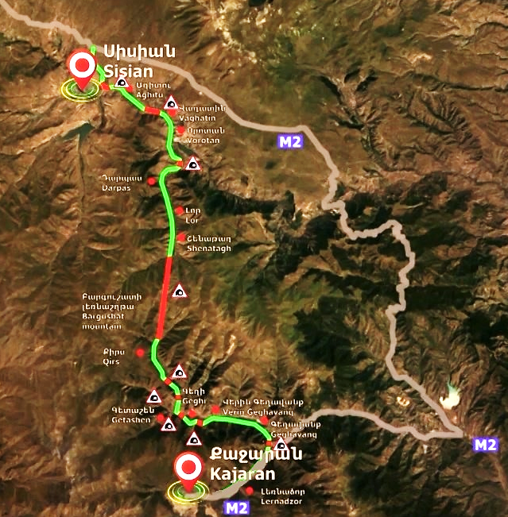

- Design Criteria used in the Design:

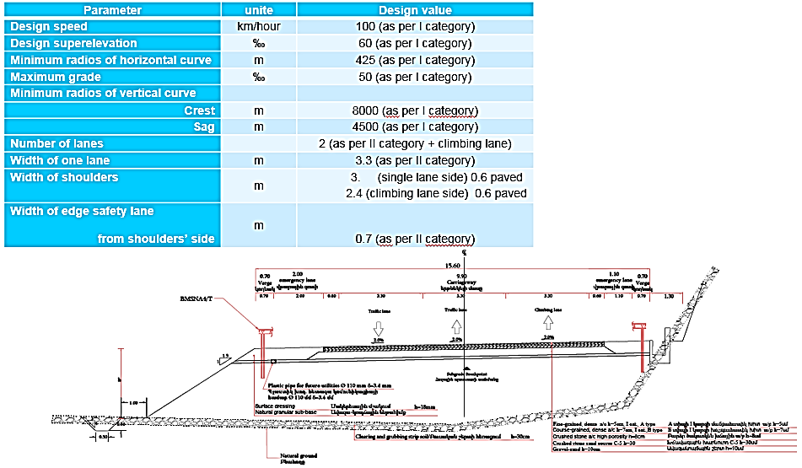

- Design Standards and design technical solutions:
The standards and regulations in Armenia are set by Ministry of Urban Development. The list of all standards and guidelines for design and construction of all sectors as well as requirements and testing methods for construction materials are published in the Ministry of Urban Development official website. Design of roads and highways in Armenia must be implemented according to the Automobile road CHPA IV-11.05.02-99 design standards.
The design of all main structures has been developed according with both the current Armenian Standards and European technical Standards, which are represented by Eurocodes.
The following table resumes the main Eurocode parts used for the design of concrete, steel and composite bridges respectively. The seismic calculation and verification were carried out combining Armenian Code in compliance with Eurocodes.
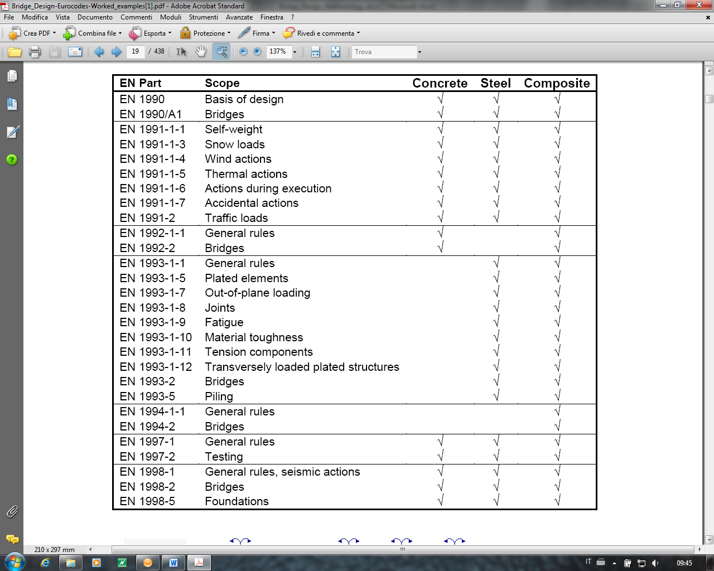
The typical cross section is made by one lane for each direction of movement plus an extra climbing lane everywhere (except the tunnel section only in the ascendant direction).
Two shoulders both sides with total width 3.30 m on the side of the single lane and 2.40 m on the side of the climbing lane. In cut sections with longitudinal length of more than 100 meters, the width of the shoulder has been decreased to 1,80 m, in order to minimize the volume of excavation.
The total width of the paved road is 11.10 m. Both shoulders have 0.6 m asphalt paved. The minimum width of verge is 0.70 m.
The typical cross section will have the following parameters:
- 1 lanes for each directions + 1 climbing lane;
- Lanes width 3.30 m;
- Width of emergency lane 3,30 m / 2,40-1,80 m;
- Verge width 0,70 m;
- Embankment slopes 1/1.5.
The minimum rate of cross slope applicable to the travelled way is determined by drainage needs. Consistent with the category of road and amount of rainfall, snow, and ice the usually accepted minimum values for cross slope range from 12‰ to 30‰.
In order to consider also the snow and ice safety consideration, the minimum slope in straight for the cross section used is 20‰. In straight the slope direction is based on hydraulic consideration and the direction is variable along the alignment and it is directed to the valley side.
The maximum slope in curve is 60‰.
The rotation point of the carriageway is located along the axis, that means in the median position related to the paved carriageway.
In the cut sections, the maximum high of the cut is 10 m, the slope of the cut is related to the type of soil. Every 10 m, 2 m bench is located to assure the stability of the cut and to accommodate the rolling material coming from the top.
- Summary of road design criteria:

Design speed | km/hour | 100 (as per I category)
Design superelevation | ‰ | 60 (as per I category)
Minimum radios of horizontal curve | m | 425 (as per I category)
Maximum grade | ‰ | 50 (as per I category)
Minimum radios of vertical curve
Crest | m | 8000 (as per I category)
Sag | m | 4500 (as per I category)
Number of lanes |  | 2 (as per II category + climbing lane)
Width of one lane | m | 3.3 (as per II category)
Width of shoulders | m | - (single lane side) 0.6 paved  2.4/1,8 (climbing lane side) 0.6 paved
Width of edge safety lane  from shoulders’ side | m | 0.7 (as per II category)

- Interchanges
Localization of the 3 main interchanges were fixed:
- No 1 – Sisian
- No 2 – Darbas
- No 3- in connection with existing M2 nearby Kajaran

The interchange No. 1 is located at begin of the project and it is needed in order to re-establish the connection with the existing M2 road in Kapan direction. It is also needed to allow the possibility of connection with the other minor road access to Kapan and to the village shown in the following picture.
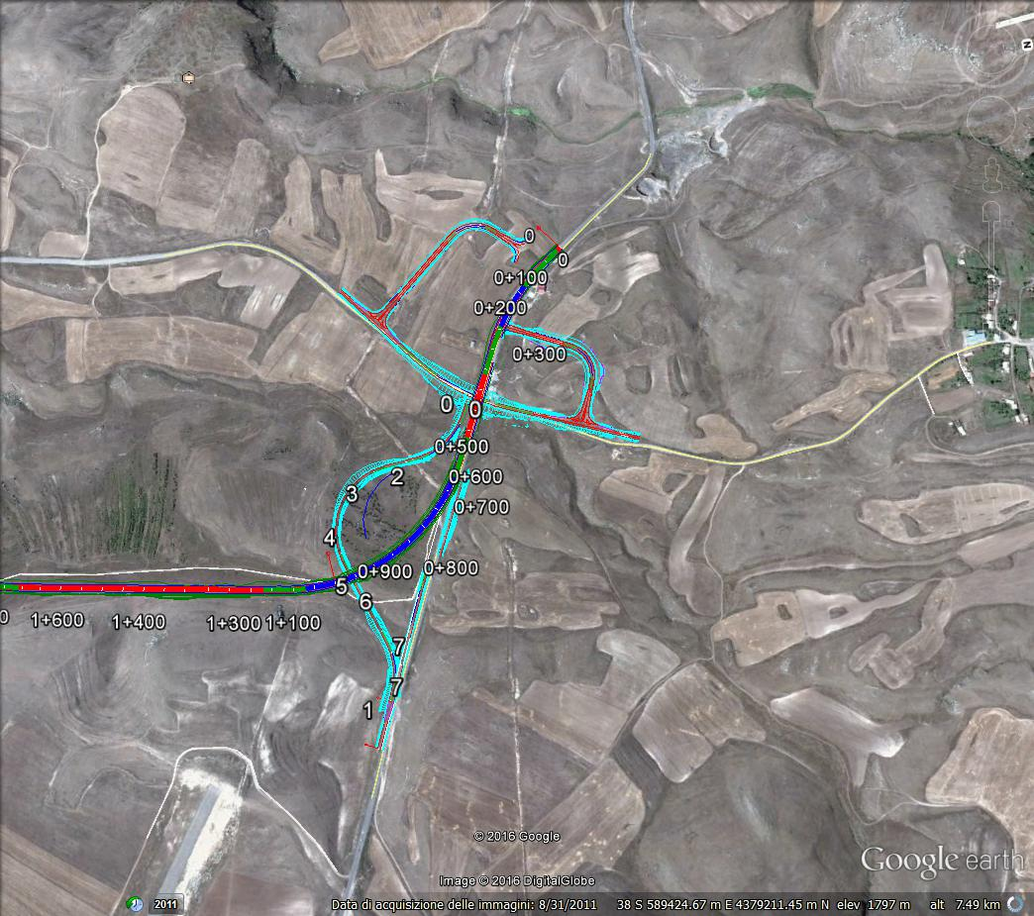
The interchange No. 2 is located at km 15+900 and it is needed in order to re-establish the connection with the existing roads in the area of Shamb Reservoir (shown in the following picture).
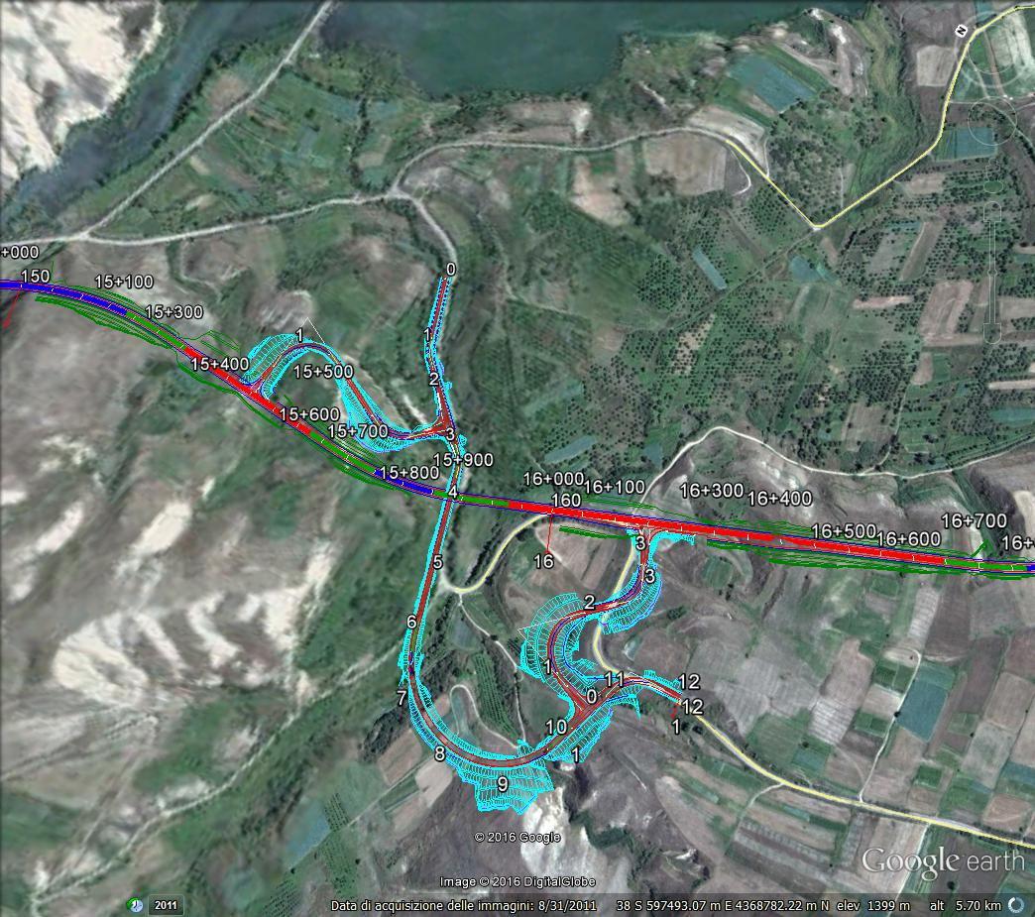
The interchange No. 3 is located approximately at km 57+500 and it is needed in order to re-establish the connection with the existing M2 road and to connect the new road with the East part of the Armenia such as Kapan, Syunik (shown in the following picture).
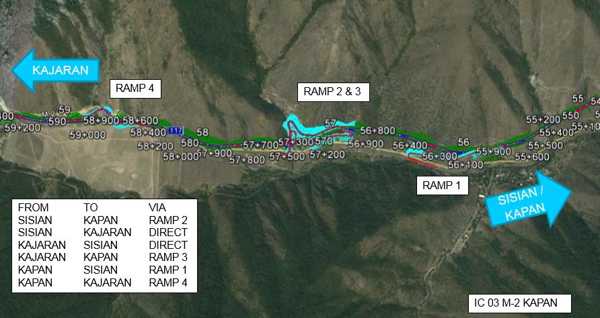
- Main structures:
Main structures of the project consist of bridges aimed to cross valley, rivers or other kind of obstacles.
The total number of bridges were 27, and they were grouped into the following main typologies:
- Steel-concrete bridges: maximum span length up to 72 m;
- Precast concrete bridges: maximum span up to 28 m.

- Tunnels:
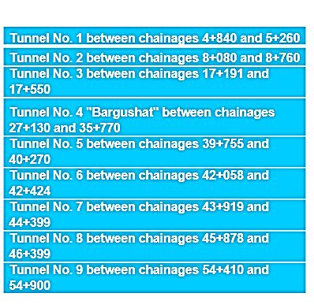
The design of the typical tunnels cross section satisfies the prescriptions of the “Safety Requirements for Tunnels in the Trans-European Road Network Regulations” (Directive 2004/54/EC) for bi-directional tunnels of less than 1000 meters.
These tunnels are characterized by the following safety equipment:
- SOS and fire extinguisher every 250 m
- Lighting system
- Active safety signage.

For the Bargushat tunnel (tunnel n. 4), with a total length of 8640 m, the adopted cross section satisfies the prescriptions of the “Safety Requirements for Tunnels in the Trans-European Road Network Regulations” (Directive 2004/54/EC) for bi-directional tunnels of more than 1000 m.
Particularly:
- two fans and one duct in the vault of the tunnels provide the required capacity for the fresh air supply and for the exhaust air and smoke extraction (semi-trasversal ventilation),
- a separate duct under the pavement, between the carriageway and the tunnel invert, guarantees the escape way in case of fire accident.

The Bargushat tunnel is characterized by the following safety equipment:
- Widening for emergency every 1000 m
- Escape way under the pavement
- Access to escape way every 500 m
- SOS and fire extinguisher every 250 m
- Lighting system
- Fire system with water tanks at portals
- Longitudinal ventilation
- Upper channel for extraction of smoke
- Ventilation station at portals
- Active safety signage.

Tunnels will be equipped with plants that can meet high safety standards.
Among the objectives considered for the design of technological systems, the most important ones are:
- ensuring a good level of driving comfort for road users;
- comply with applicable regulatory requirements;
- ensure high reliability of installations, using state-of-the-art electrical and electronic equipment;
- provide traffic monitoring and monitoring systems that can alert risk situations (accident, fire, etc.);
- ensuring secure and reliable communications between users in the area or along the protected escape routes and the Infrastructure Operations Center;
- ensure an important level of availability of electricity distribution, ensuring the operation of essential plants even in the event of interruption of the power supply;
- ensure correct air supply in the tunnel under the different traffic conditions (fluid, congested) and avoid fumes in the event of a fire;
- standardize, as far as possible, the type of equipment envisaged, in order to optimize the operation and maintenance;
- limit as far as possible the economic burden of first installation, maintenance and operation.

To achieve the above objectives, the design also provides the solutions for the construction of the following elements:
- power supply systems
- lighting plants
- fire detection systems
- SOS Emergency stations
- Light Road signs
- Radio Plants
- Firefighting systems
- Control, automation and supervision systems
- TVcc Systems
- Control Centres

- Underpasses:
Two different types of underpasses were provided along the new infrastructure:
- Animal underpass 5,00 x 3,00 in order to allow the passage of animals;
- Agricultural underpass 5,50 x 10,00 in order to link from one side to the other minor rural roads.

Animal underpasses are foreseen at the following locations: km 2+700, km14+250, km 38+840 and km 47+921. Agricultural underpasses are foreseen at the following locations: km 5+779, km 7+057, km 47+921.
- Typical hydraulic boxes and pipes culvert:
Along the project 124 hydraulic culvert are identified.
4 different type of box culverts are provided:
- 1,00 x 1,00 – 1 unit;
- 1,50 x 1,50 – 95 unit;
- 2,00 x 2,00 – 18 unit;
- 3,00 x 3,00 – 10 unit.

- Typical retaining walls:
104 different concrete retaining walls are provided along the road, with a total length of about 5000 m. Various height are requested from 1,00 meter up to 11,00 m.

- Pavement:

No | Layer name | Unit | Thickness
1 | Plant mix asphalt, wearing course | mm | 50
2 | Plant mix asphalt, base course | mm | 70
3 | Plant mix crushed stone sand mix with bitumen (binder course) | mm | 80
4 | Crushed stone base | mm | 300
5 | Sand-gravel sub base | mm | 100
TOTAL |  | mm | 600

- Construction works main quantities:

Item description | Approximately Quantity
Excavation | 16 mln. m³
Embankment & Backfill | 4 mln. m³
Hot asphalt pavement (h=7 cm) | 0.6 mln. m²
Hot asphalt pavement (h=5 cm) | 0.7 mln. m²
Concrete | 0.7 mln. m³

- The net estimated duration of the construction works envisaged by the program will be about 6 years.

For each matter disclosed, provide details of the measures that were taken, or shall be taken, to ensure that neither the disclosed entity nor any of its directors, employees or agents commits any Prohibited Conduct in connection with the procurement process for the Contract.

