Հավելված N 2
ՀՀ կառավարության 2022 թվականի
սեպտեմբերի 22-ի N - Ն որոշման




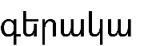
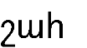
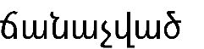


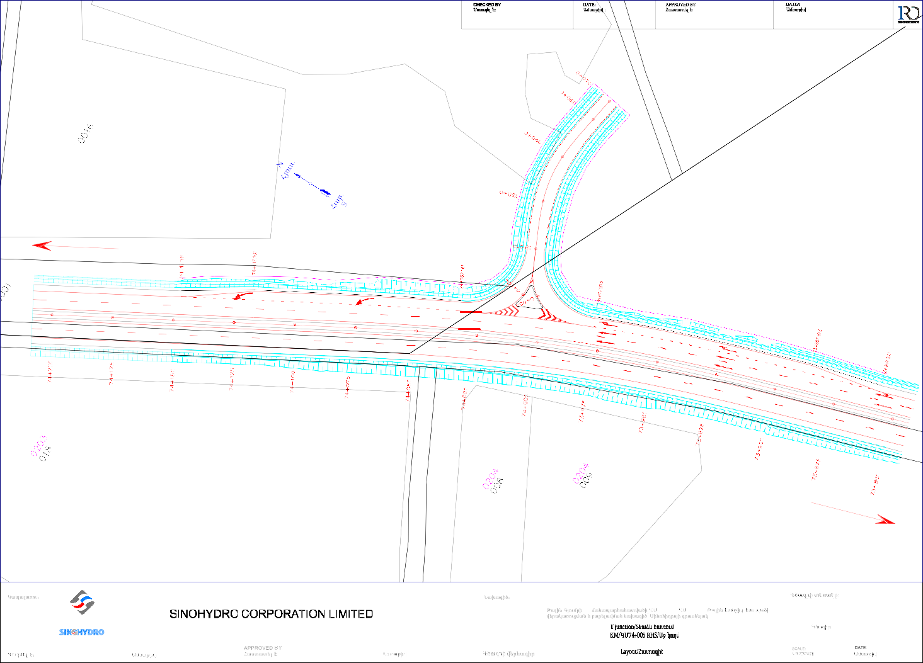
Gyumri/Գյումրի
Yerevan/Երևան

CONTRACTOR: |  |  |  | PROJECT : Reconstruction and improvement of the M1 Talin to Gyumri Road from km71+500 to km90+200(Talin-Lanjik Section) Project OF SINOHYDRO  - M1 71 +500 - 90+ 200 / - / | DRAWING TYPE:
DRAWING NO.:
:
DESIGNED BY: | DATE: |  | DATE:  : | DRAWING TITLE: |  | :

CHECKED BY:
Ստուգել է：
DATE:
Ամսաթիվ :
APPROVED BY:
Հաստատել է:
DATEA
Ամսաթիվ :

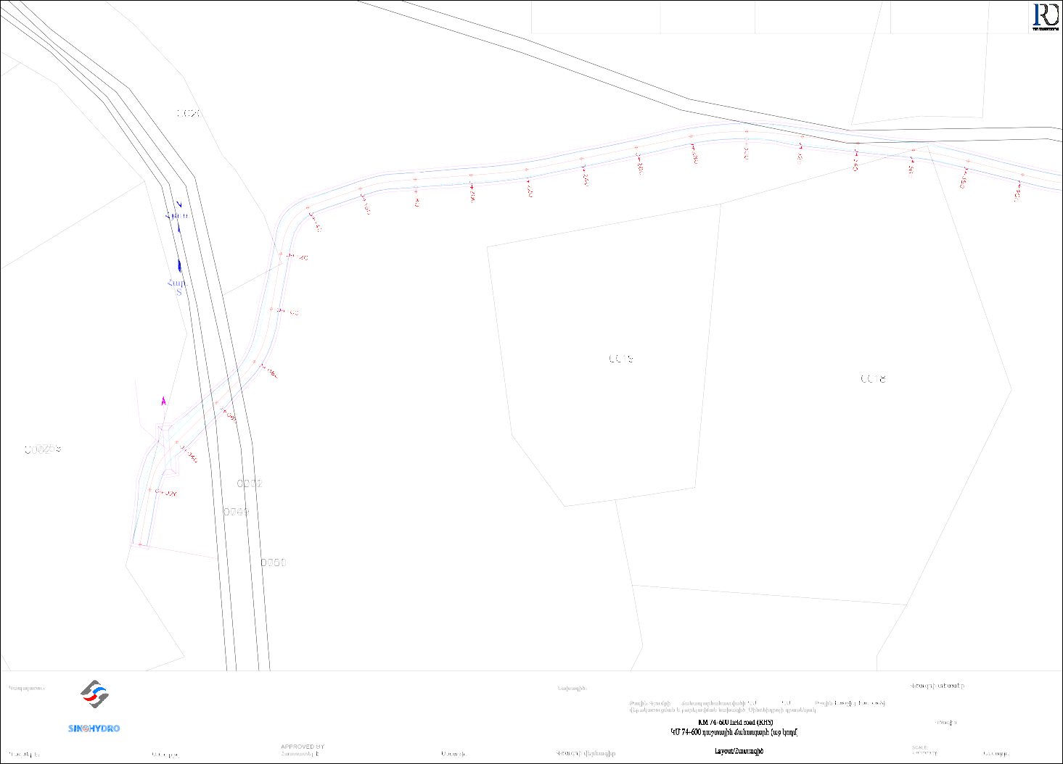
Start of design
Նախագծի սկիզբ
km/կմ 0+000
Metal pipe Մետ.
խողովակ
d=0.72 m/մ

CONTRACTOR:  SINOHYDRO CORPORATION LIMITED |  |  |  | PROJECT : Reconstruction and improvement of the M1 Talin to Gyumri Road from km71+500 to km90+200(Talin-Lanjik Section) Project OF SINOHYDRO  - M1 71 +500 - 90+ 200 / - / | DRAWING TYPE:  :
DRAWING NO.:
:
DESIGNED BY: | DATE: |  | DATE:  : | DRAWING TITLE: |  | DATE:  :

CHECKED BY:
Ստուգել է：
DATE:
Ամսաթիվ :
APPROVED BY:
Հաստատել է:
DATEA
Ամսաթիվ :

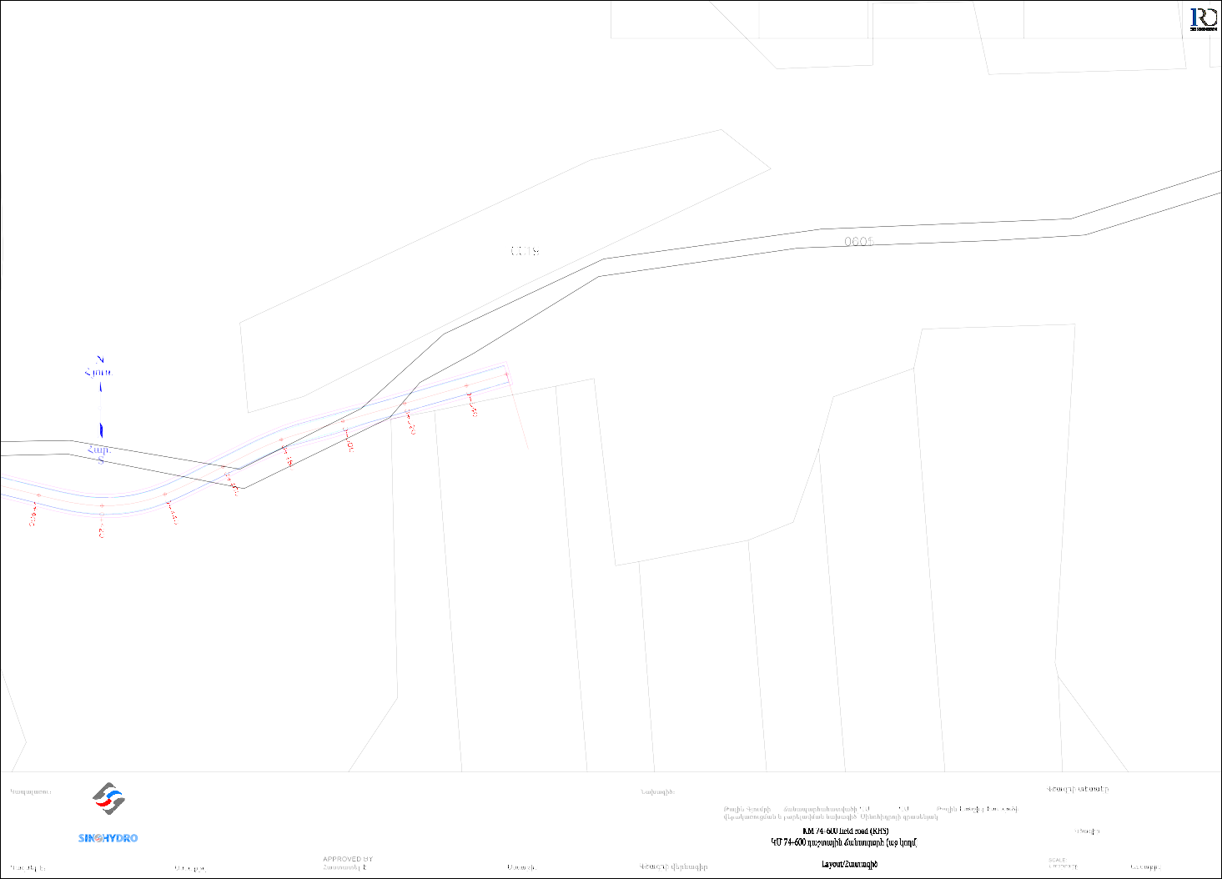
End of design
Նախագծի վերջ
km/կմ 0+553

CONTRACTOR:  SINOHYDRO CORPORATION LIMITED |  |  |  | PROJECT : Reconstruction and improvement of the M1 Talin to Gyumri Road from km71+500 to km90+200(Talin-Lanjik Section) Project OF SINOHYDRO  - M1 71 +500 - 90+ 200 / - / | DRAWING TYPE:  :
DRAWING NO.:
:
DESIGNED BY: | DATE: |  | DATE:  : | DRAWING TITLE: |  | DATE:  :

1719.73
CHECKED BY:
Ստուգել է：
DATE:
Ամսաթիվ :
APPROVED BY:
Հաստատել է:
DATEA
Ամսաթիվ :

ÐÛáõë. N

1724.79
1719.96

1724.73

1722.78

1719.61

11772244.0.211

1722.69

S
Ðmñ.

1722.39
1720

1722.37

1719.80

1722.13

1721.64

1723.82

1724.08

1720.35

1720.87
779+87.89

building

1723.64

1724.04

1722.26 կառ.

1722.40

1721.05 1722.38
Overpass KM78+015

1719.53

1723.76
1721.21
1722

1720.65
779+57.89

1718.77

1719.15

1721.85

1721.60

1722.46

1723.02

1723.18

1719.44

1720.60

1722.50
1720

1722.72

1722.66
779+35.63

1722.71

1721.88

1722.41

1722.63

1718.13

1718.13

ÐÛáõë.
1720.76

1722.83

1719.27 N
1720

1722.40

1717.73

1720.54
S

Ðmñ.

1721.26

1721.67

1721.83

1722.20

1719.85
778+75.63

1718.30

1720.81

1721.24

1721.49

1721.71

1721.26

1721.55
1718

1718.58

1719.31
CW_1*1.5*1.5 ,0+40.00
1721.56

1721.38
1722

117119..820

ÐÛáõë. N

1717.34

N
ÐÛáõë.

1720.30

1720.69
CW_

1721.01
778+15.55

CONTRACTOR:

PROJECT :

Reconstruction and improvement of the M1 Talin to Gyumri Road from km71+500 to km90+200(Talin-Lanjik Section) Project OF SINOHYDRO
DRAWING TYPE:
:

SINOHYDRO CORPORATION LIMITED

- M1
71 +500 - 90+ 200 / - /

DRAWING NO.:
:

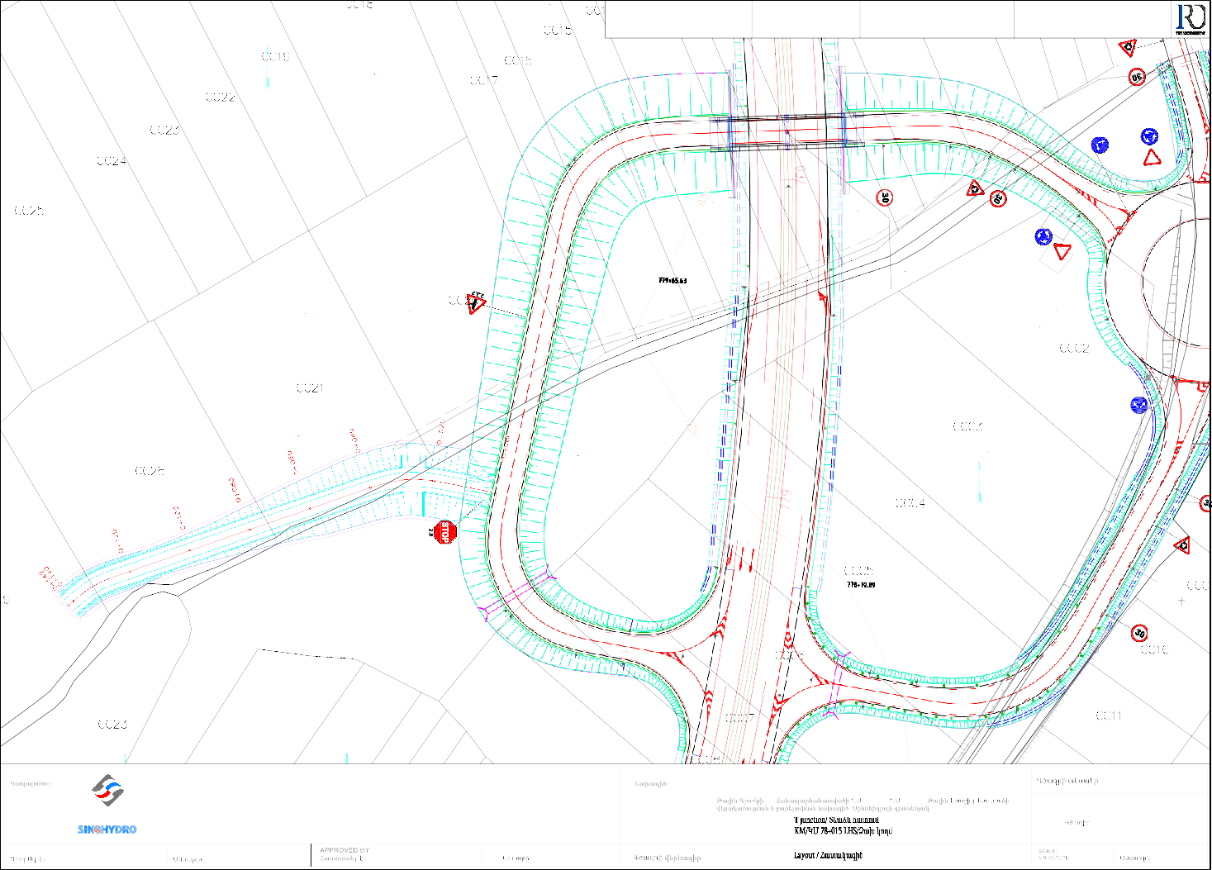
DESIGNED BY:

DATE:

DATE:
:

DRAWING TITLE:

DATE:
:

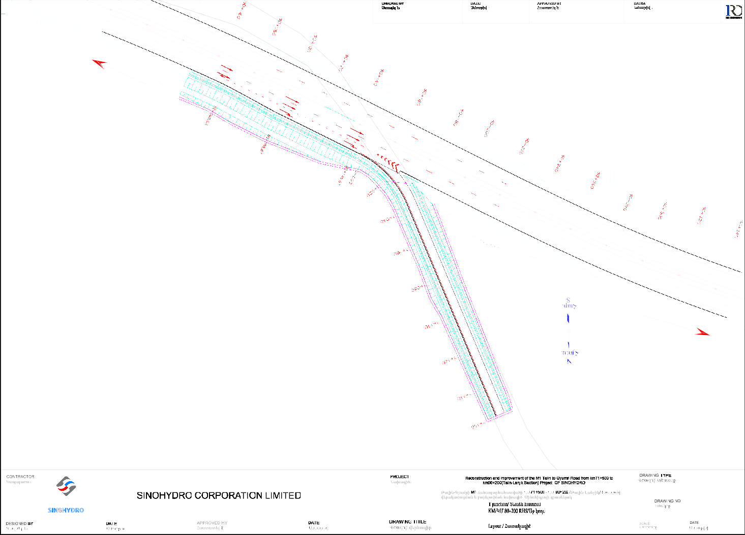
Gyumri/Գյումրի
Yerevan/Երևան

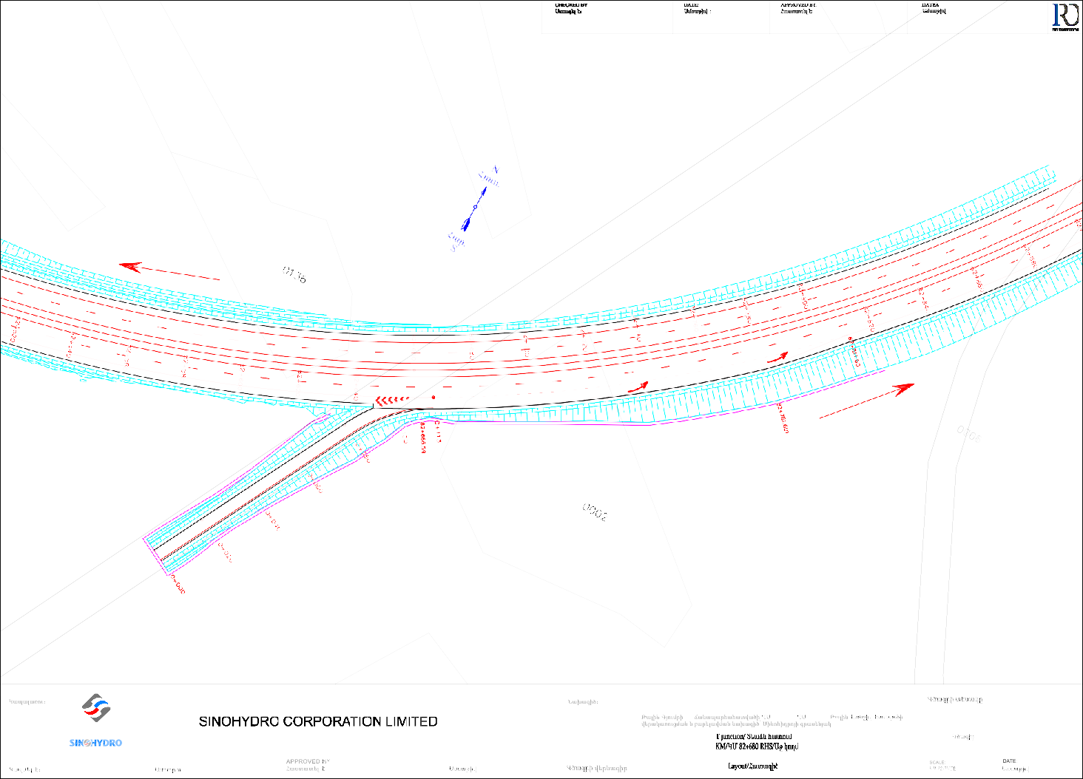
Yerevan/Երևան
Gyumri/Գյումրի

CONTRACTOR: |  |  |  | PROJECT : Reconstruction and improvement of the M1 Talin to Gyumri Road from km71+500 to km90+200(Talin-Lanjik Section) Project OF SINOHYDRO  - M1 71 +500 - 90+ 200 / - / | DRAWING TYPE:
DRAWING NO.:
:
DESIGNED BY: | DATE: |  | DATE:  : | DRAWING TITLE: |  | :

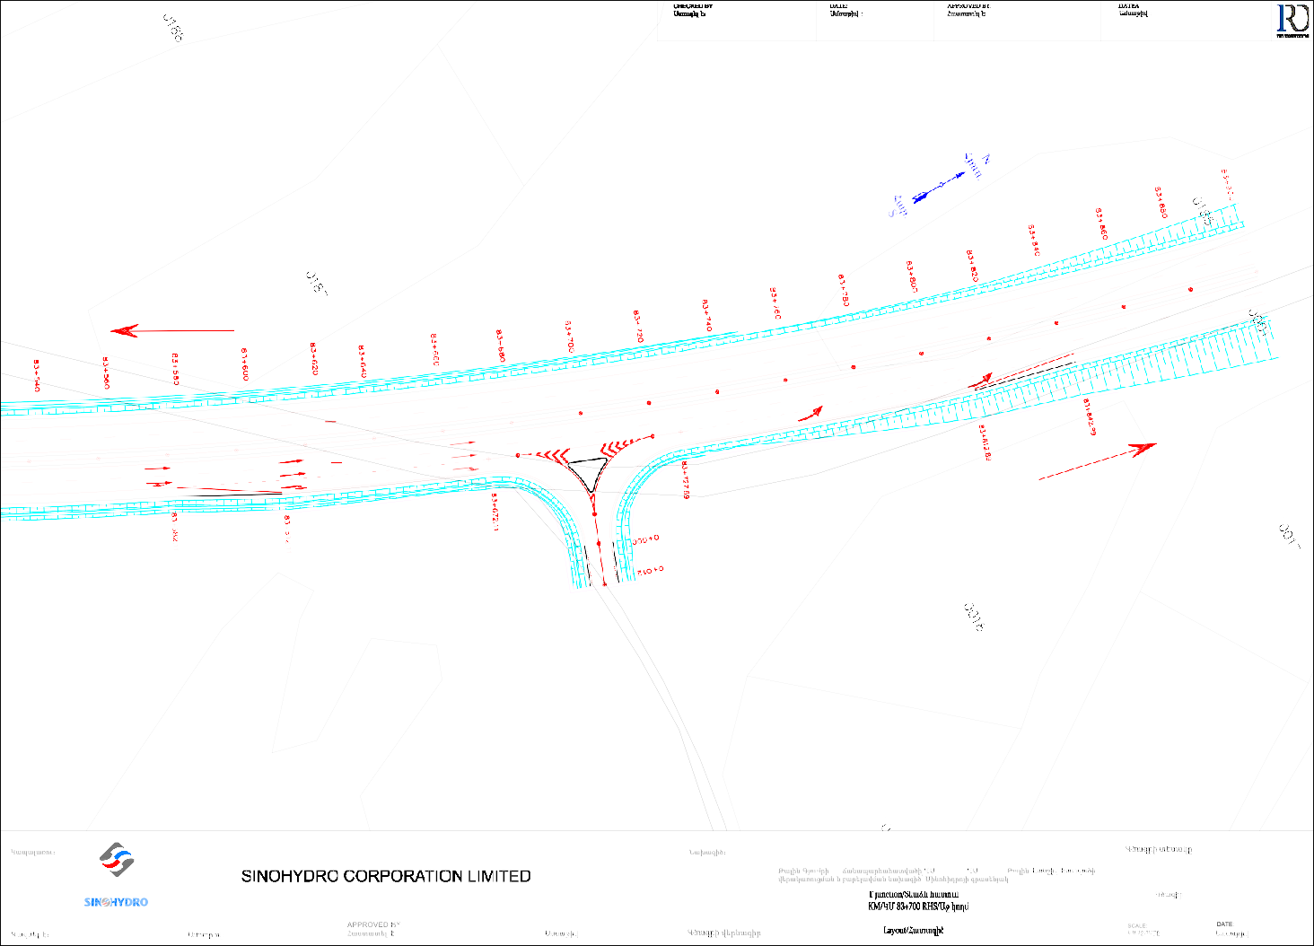
Gyumri/Գյումրի

Yerevan/Երևան

CONTRACTOR: |  |  |  | PROJECT : Reconstruction and improvement of the M1 Talin to Gyumri Road from km71+500 to km90+200(Talin-Lanjik Section) Project OF SINOHYDRO  - M1 71 +500 - 90+ 200 / - / | DRAWING TYPE:
DRAWING NO.:
:
DESIGNED BY: | DATE: |  | DATE:  : | DRAWING TITLE: |  | :

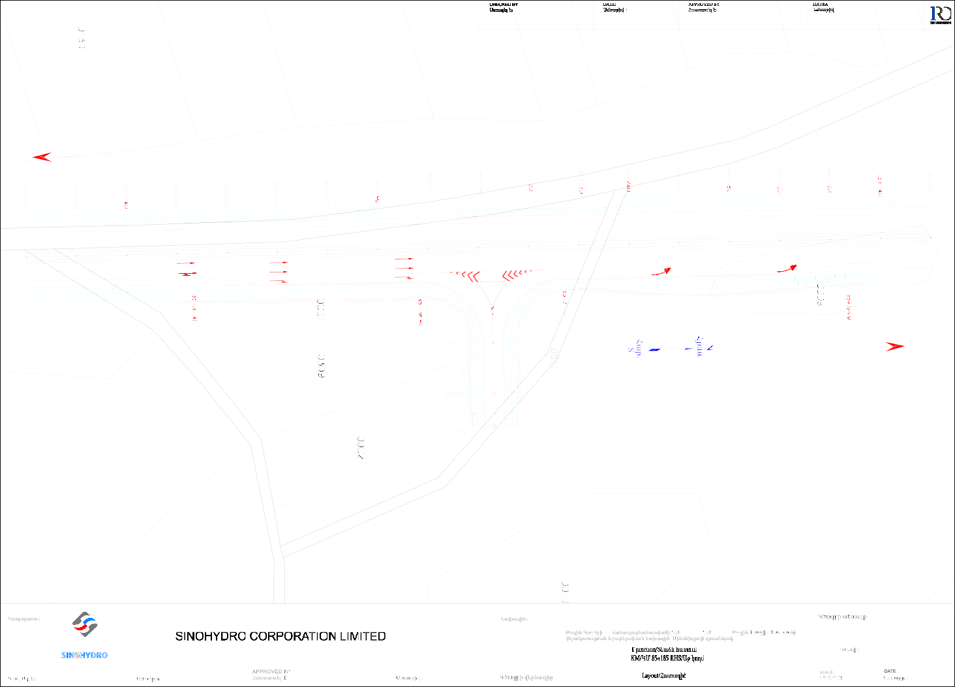
Gyumri/Գյումրի

Yerevan/Երևան

CONTRACTOR: |  |  |  | PROJECT : Reconstruction and improvement of the M1 Talin to Gyumri Road from km71+500 to km90+200(Talin-Lanjik Section) Project OF SINOHYDRO  - M1 71 +500 - 90+ 200 / - / | DRAWING TYPE:
DRAWING NO.:
:
DESIGNED BY: | DATE: |  | DATE:  : | DRAWING TITLE: |  | :

CHECKED BY:
K
Ստուգել է：
DATE:
Ամսաթիվ :
APPROVED BY:
Հաստատել է:
DATEA
Ամսաթիվ :

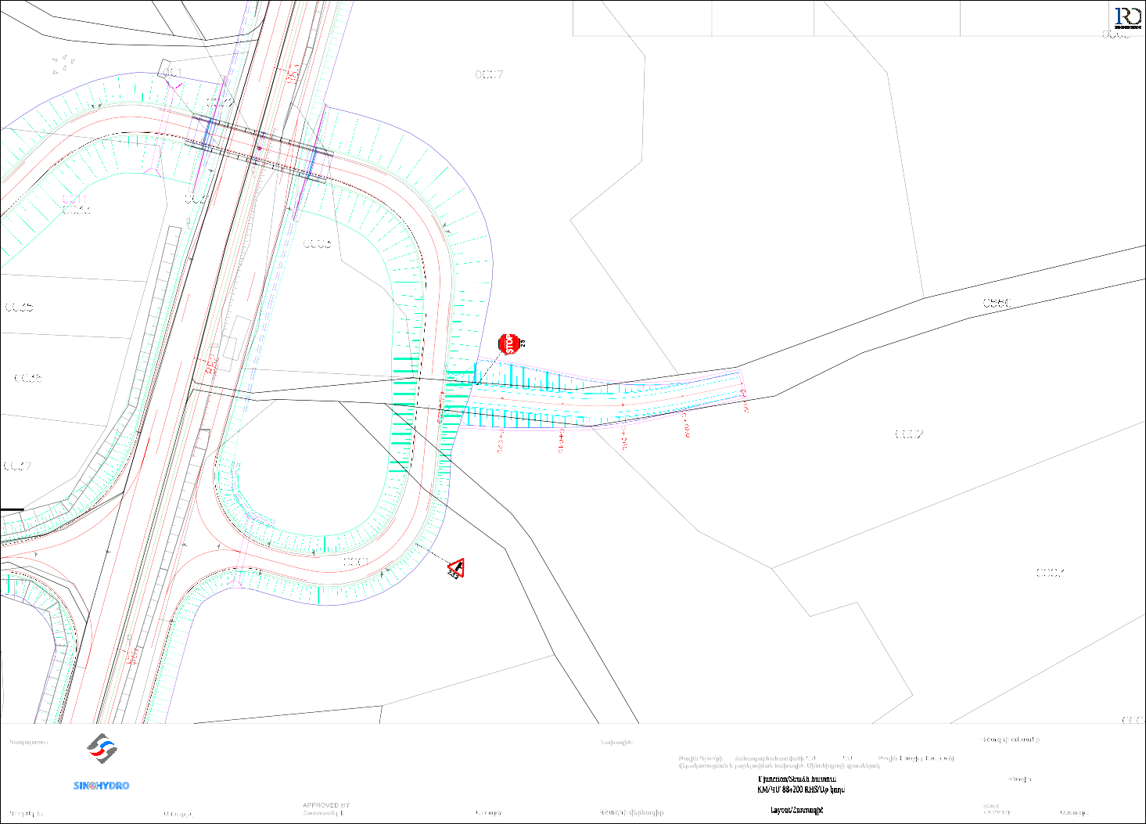
W_1*1.5*1.5 ,0+08.00

s/ք
CW_1*1.5*1.5 ,2+50.00

CONTRACTOR: |  |  |  | PROJECT : Reconstruction and improvement of the M1 Talin to Gyumri Road from km71+500 to km90+200(Talin-Lanjik Section) Project OF SINOHYDRO | DRAWING TYPE:  :
SINOHYDRO CORPORATION LIMITED |  |  |  | - M1 71 +500 - 90+ 200 / - / | DRAWING NO.:  :
DESIGNED BY: | DATE: |  | DATE:  : | DRAWING TITLE: |  | DATE:  :

CHECKED BY:
Ստուգել է：
DATE:
Ամսաթիվ :
APPROVED BY:
Հաստատել է:
DATEA
Ամսաթիվ :

Start of design
Նախագծի սկիզբ
km/կմ 0+000
Metal pipe Մետ.
խողովակ
d=0.72 m/մ

CONTRACTOR:  SINOHYDRO CORPORATION LIMITED |  |  |  | PROJECT : Reconstruction and improvement of the M1 Talin to Gyumri Road from km71+500 to km90+200(Talin-Lanjik Section) Project OF SINOHYDRO  - M1 71 +500 - 90+ 200 / - / | DRAWING TYPE:  :
DRAWING NO.:
:
DESIGNED BY: | DATE: |  | DATE:  : | DRAWING TITLE: |  | DATE:  :

CHECKED BY:
Ստուգել է：
DATE:
Ամսաթիվ :
APPROVED BY:
Հաստատել է:
DATEA
Ամսաթիվ :

End of design
Նախագծի վերջ
km/կմ 0+553

CONTRACTOR:  SINOHYDRO CORPORATION LIMITED |  |  |  | PROJECT : Reconstruction and improvement of the M1 Talin to Gyumri Road from km71+500 to km90+200(Talin-Lanjik Section) Project OF SINOHYDRO  - M1 71 +500 - 90+ 200 / - / | DRAWING TYPE:  :
DRAWING NO.:
:
DESIGNED BY: | DATE: |  | DATE:  : | DRAWING TITLE: |  | DATE:  :

1719.73
CHECKED BY:
Ստուգել է：
DATE:
Ամսաթիվ :
APPROVED BY:
Հաստատել է:
DATEA
Ամսաթիվ :

ÐÛáõë. N

1724.79
1719.96

1724.73

1722.78

1719.61

11772244.0.211

1722.69

S
Ðmñ.

1722.39
1720

1722.37

1719.80

1722.13

1721.64

1723.82

1724.08

1720.35

1720.87
779+87.89

building

1723.64

1724.04

1722.26 կառ.

1722.40

1721.05 1722.38
Overpass KM78+015

1719.53

1723.76
1721.21
1722

1720.65
779+57.89

1718.77

1719.15

1721.85

1721.60

1722.46

1723.02

1723.18

1719.44

1720.60

1722.50
1720

1722.72

1722.66
779+35.63

1722.71

1721.88

1722.41

1722.63

1718.13

1718.13

ÐÛáõë.
1720.76

1722.83

1719.27 N
1720

1722.40

1717.73

1720.54
S

Ðmñ.

1721.26

1721.67

1721.83

1722.20

1719.85
778+75.63

1718.30

1720.81

1721.24

1721.49

1721.71

1721.26

1721.55
1718

1718.58

1719.31
CW_1*1.5*1.5 ,0+40.00
1721.56

1721.38
1722

117119..820

ÐÛáõë. N

1717.34

N
ÐÛáõë.

1720.30

1720.69
CW_

1721.01
778+15.55

CONTRACTOR:

PROJECT :

Reconstruction and improvement of the M1 Talin to Gyumri Road from km71+500 to km90+200(Talin-Lanjik Section) Project OF SINOHYDRO
DRAWING TYPE:
:

SINOHYDRO CORPORATION LIMITED

- M1
71 +500 - 90+ 200 / - /

DRAWING NO.:
:

DESIGNED BY:

DATE:

DATE:
:

DRAWING TITLE:

DATE:
:

Gyumri/Գյումրի
Yerevan/Երևան

Yerevan/Երևան
Gyumri/Գյումրի

CONTRACTOR: |  |  |  | PROJECT : Reconstruction and improvement of the M1 Talin to Gyumri Road from km71+500 to km90+200(Talin-Lanjik Section) Project OF SINOHYDRO  - M1 71 +500 - 90+ 200 / - / | DRAWING TYPE:
DRAWING NO.:
:
DESIGNED BY: | DATE: |  | DATE:  : | DRAWING TITLE: |  | :

Gyumri/Գյումրի

Yerevan/Երևան

CONTRACTOR: |  |  |  | PROJECT : Reconstruction and improvement of the M1 Talin to Gyumri Road from km71+500 to km90+200(Talin-Lanjik Section) Project OF SINOHYDRO  - M1 71 +500 - 90+ 200 / - / | DRAWING TYPE:
DRAWING NO.:
:
DESIGNED BY: | DATE: |  | DATE:  : | DRAWING TITLE: |  | :

Gyumri/Գյումրի

Yerevan/Երևան

CONTRACTOR: |  |  |  | PROJECT : Reconstruction and improvement of the M1 Talin to Gyumri Road from km71+500 to km90+200(Talin-Lanjik Section) Project OF SINOHYDRO  - M1 71 +500 - 90+ 200 / - / | DRAWING TYPE:
DRAWING NO.:
:
DESIGNED BY: | DATE: |  | DATE:  : | DRAWING TITLE: |  | :

CHECKED BY:
K
Ստուգել է：
DATE:
Ամսաթիվ :
APPROVED BY:
Հաստատել է:
DATEA
Ամսաթիվ :

W_1*1.5*1.5 ,0+08.00

s/ք
CW_1*1.5*1.5 ,2+50.00

CONTRACTOR: |  |  |  | PROJECT : Reconstruction and improvement of the M1 Talin to Gyumri Road from km71+500 to km90+200(Talin-Lanjik Section) Project OF SINOHYDRO | DRAWING TYPE:  :
SINOHYDRO CORPORATION LIMITED |  |  |  | - M1 71 +500 - 90+ 200 / - / | DRAWING NO.:  :
DESIGNED BY: | DATE: |  | DATE:  : | DRAWING TITLE: |  | DATE:  :


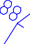
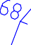

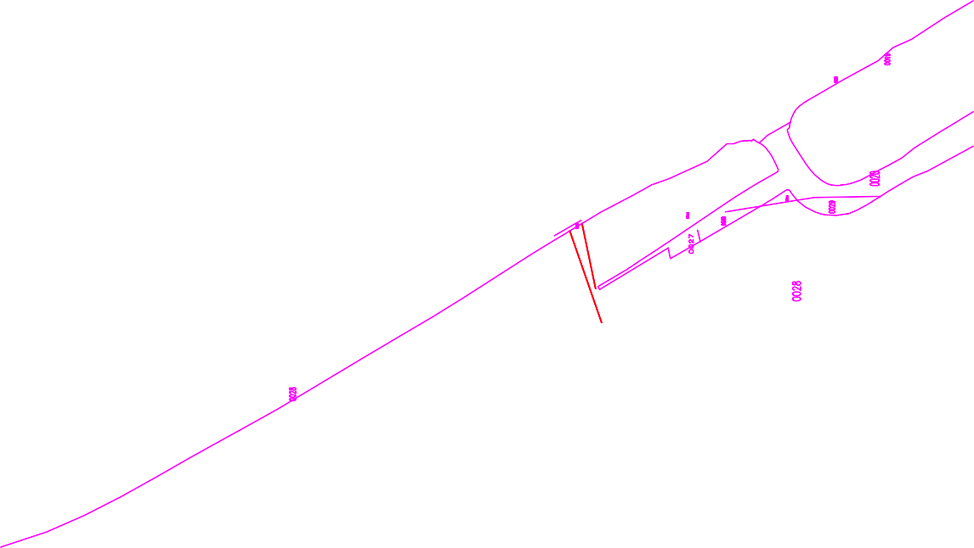

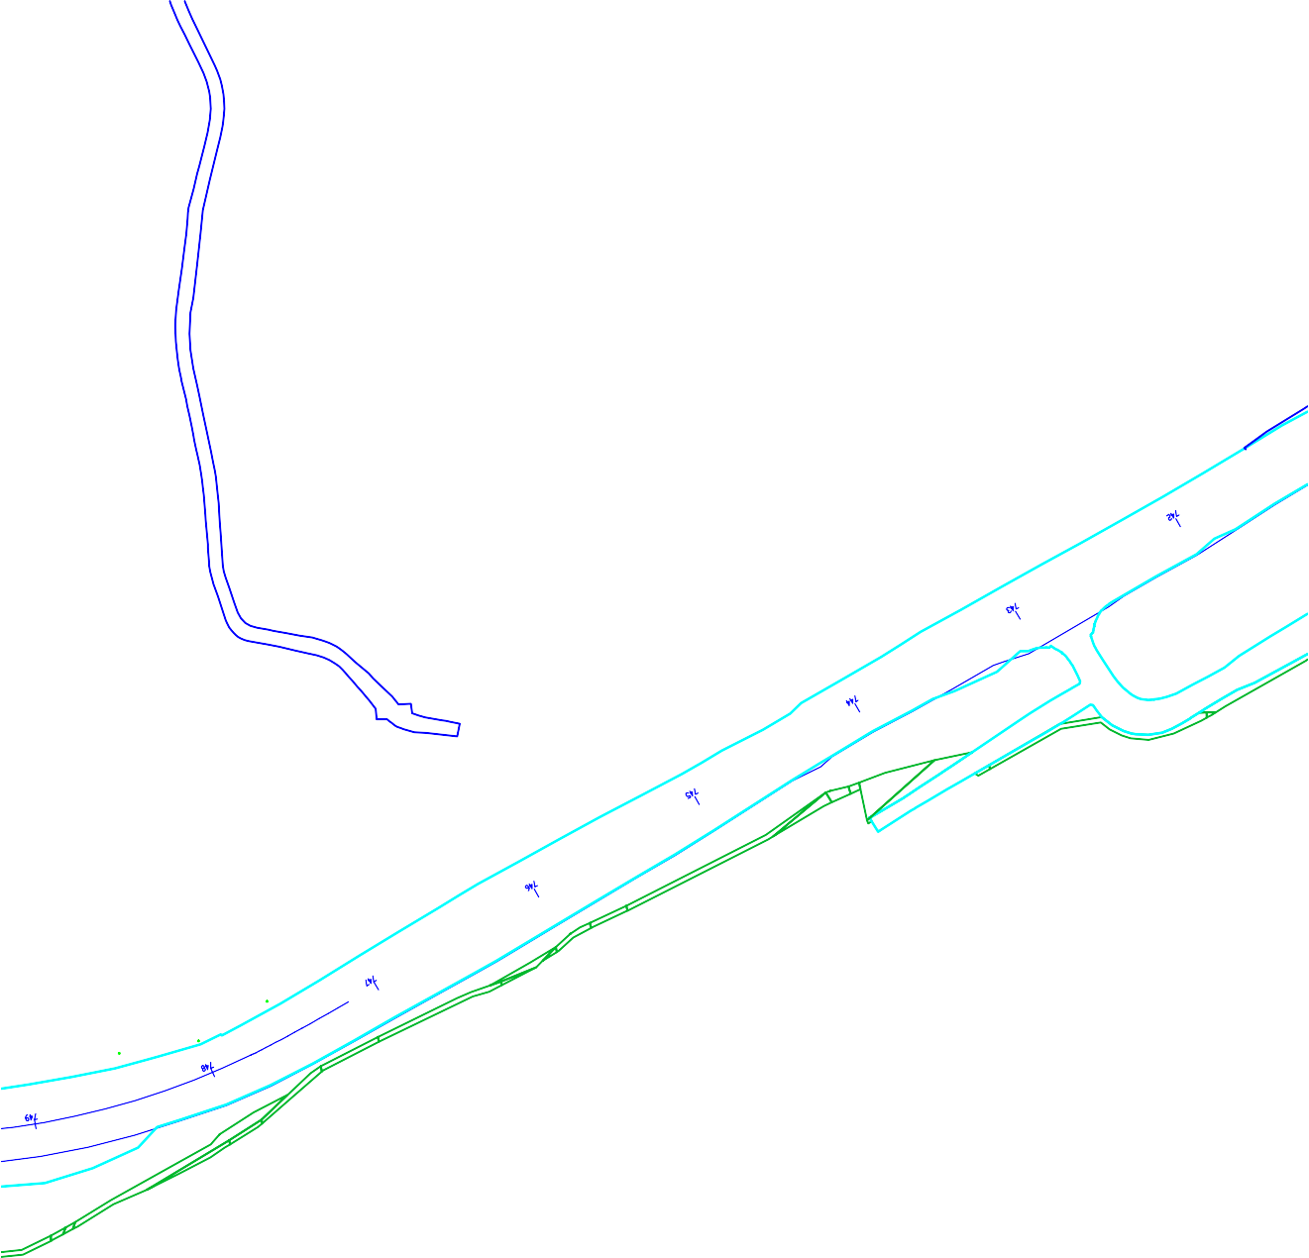

ՀԱՅԱՍՏԱՆԻ ՀԱՆՐԱՊԵՏՈՒԹՅԱՆ
ՎԱՐՉԱՊԵՏԻ ԱՇԽԱՏԱԿԱԶՄԻ
ՂԵԿԱՎԱՐ Ա. ՀԱՐՈՒԹՅՈՒՆՅԱՆ

